**Job # 1**

**To prepare layout of strength of materials lab**

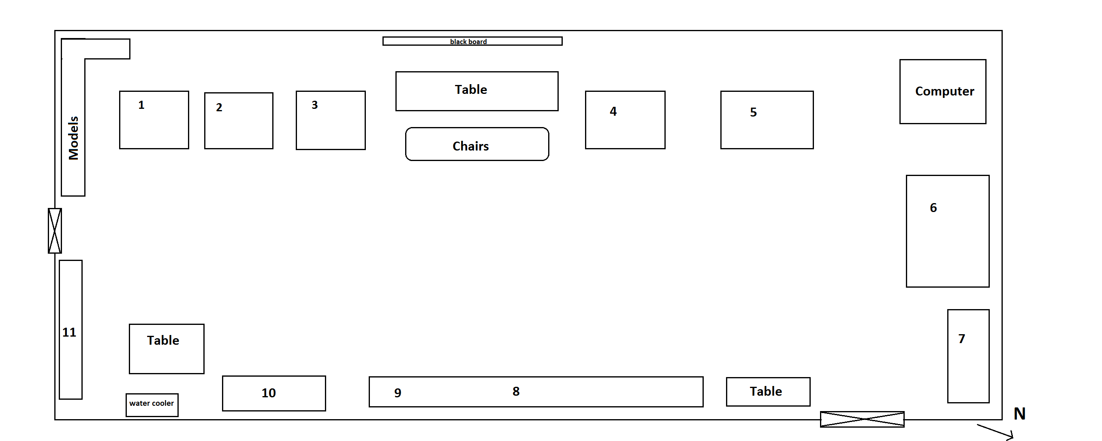

1. 10 ton Buckton UTM
2. 50 ton Denison UTM
3. Shimadzu 500kN tension testing machine
4. Avery torsion testing machine
5. Charpy impact testing machine
6. 100 ton Buckton UTM
7. Models of beams
8. Avery and Shimadzu Rockwell hardness testing machine
9. Brinell hardness testing machine

**10.** Shimadzu fatigue testing machine

**11.** Samples of bricks and tiles

**Some important terms:**

**Layout:**

It is a drawing or plan which shows the arrangement of various objects.

**Universal testing machine:**

Any machine which can perform tension, compression and bend test.

**Hardness:**

Resistance to plastic deformation or penetration is known as hardness.

**Fatigue:**

Repeated loadings which causes reversal of stresses in material is known as fatigue.

**Machines in laboratory:**

1. **10 ton Buckton UTM:**

**Max. capacity:** 10 tons

**Manufacturer:** Joshua Buckton and CO. LTD.

**Operation:** Electric/ manual lever arm system

**Parts:** Upper part fixed and Lower part moveable

**Tests:**

1. Tension
2. Compression
3. Bending
4. Shear
5. Punching
6. 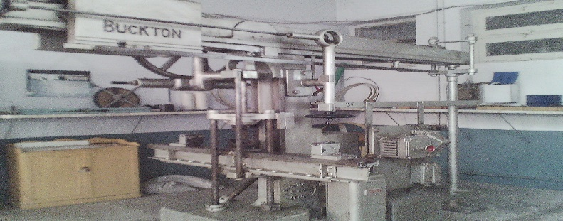Torsion
7. **50 ton Denison UTM:**

**Max. capacity:** 50 tons

**Manufacturer:** Smal. Denison & son ltd.

**Operation:** Electric hydraulic system

**Parts:** Upper part is fixed, lower part is moveable

**Tests:**

1. Tension
2. Compression
3. Bending

**Scales:**

0-5 tons 0- 25 tons

0-10 tons 0-50 tons

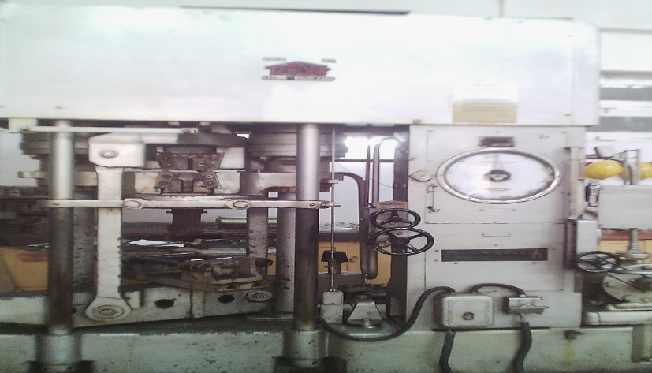

1. **50 tons Shimadzu UTM:**

**Max. capacity:** 50 tons

**Manufacturer:** Shimadzu

**Operation:** electric

**Parts:**

**Tests:**

1. Compression
2. Bending
3. tension

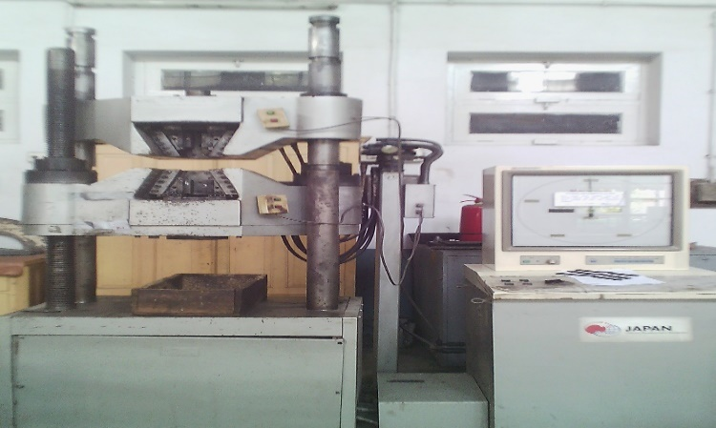

1. **Avery torsion testing machine:**

**Max. capacity:** 15000 lb in

**Manufacturer:** W. & T. AVERY LTD. BRIMINGHAM, ENGLAND

**Operation:** Electric

**Parts:** Fixed head and twisting head

**Tests: torsion test**

**Scales:**

0-1500 lb in 0-7500 lb in

0-3000 ln in 0-15000 lb in

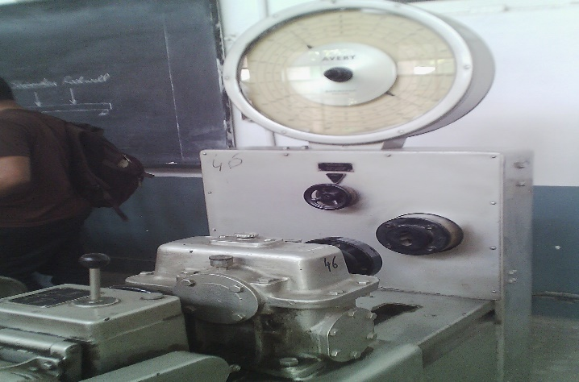

1. **Charpy impact testing machine:**

**Max. capacity:** 0-170 degree

**Manufacturer:** CHARPY LTD. ENGLAND

**Operation:** Manual

**Tests:**

1. Impact test (tension)
2. Impact test (bending)

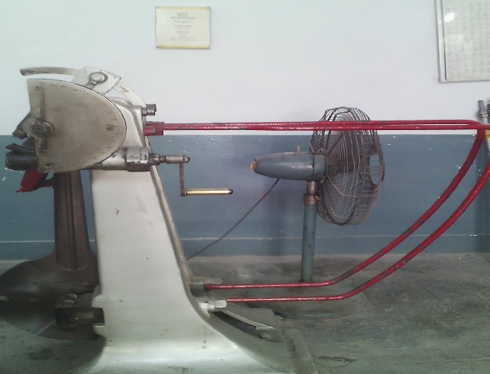

1. **100 ton Buckton UTM:**

**Max. capacity:** 200,000 lb

**Manufacturer:** Joshua Buckton & CO. LTD.

**Operation:** Electric

**Parts:** Upper part is fixed & lower part is moveable

**Tests:**

1. Torsion
2. Compression
3. Bending

**Scales:**

20,000 lb 200,000 lb

I ton = 20 lb

L.C = 2000 lb

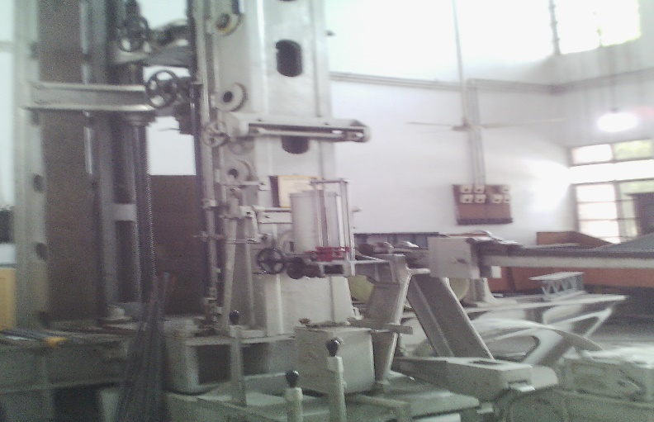

1. **Models of different structural elements:**

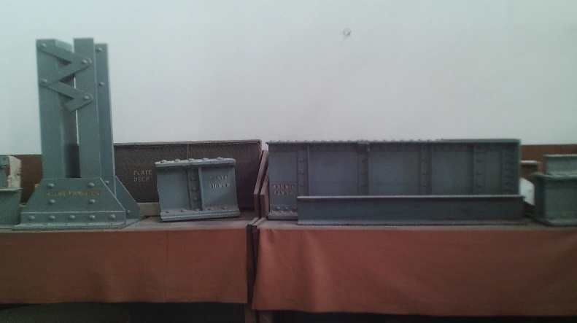

1. **Avery Rockwell hardness testing machine:**

**Max. capacity:**

**Manufacturer:** W. & T. AVERY LTD. BRIMINGHAM, ENGLAND

**Operation:** Manual

**Tests**: Hardness test

**Scales:**

Scale for low carbon steel

Scale for high carbon steel

**Penetrators:**

Steel ball 1/16 in. dia for low carbon steel

Diamond cone for high carbon steel

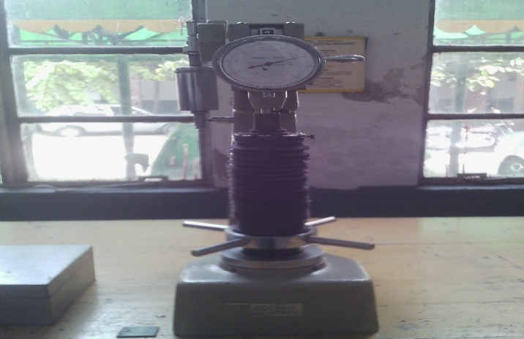

1. **Brinell hardness testing machine:**

**Manufacturer:** Brinella Poland

**Operation:** Manual

**Tests:** Hardness test

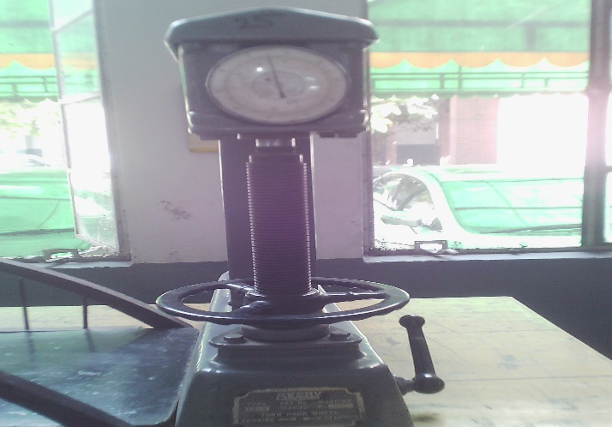

1. **Shimadzu fatigue testing machine:**

**Manufacturer:** Shimadzu

**Operation:** Electric

**Test:** Fatigue test

