Experiment #3

“Verification of Castigliano’s Theorem
And
Maxwell Law of Reciprocal Deflection by bending of beams”

Objective:-
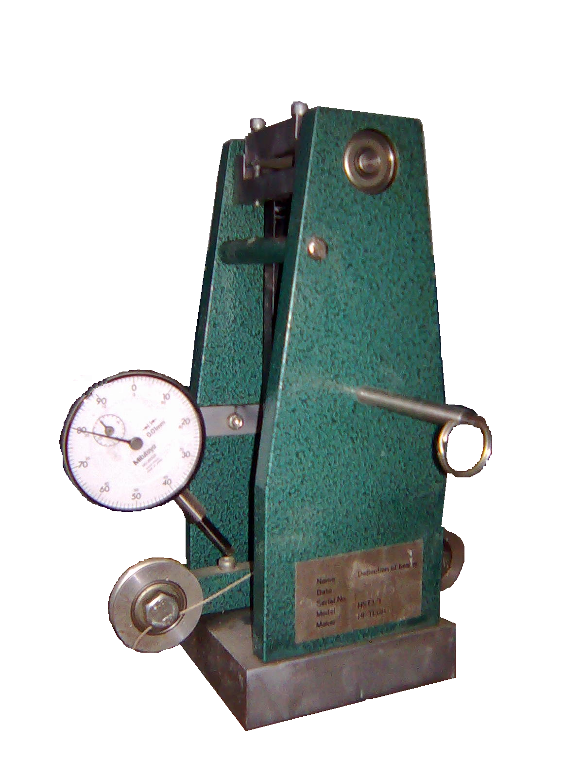
The objective of experiment is to investigate the castigliano’s method of calculating beam displacement to observe the reciprocity of displacement as stated by Maxwell.

Apparatus:-
- Steel beam
- Deflection of beam apparatus
- End support with clamping fixture and hanger
- End support with roller fixture and hanger
- Weights

Related Theory

Strain Energy For Axially Loaded Bar:-

F
Δ
A
L

$\begin{aligned}σ_{\text{axial}}=\frac{F}{A};\text{}Δ=\frac{\text{FL}}{\text{AE}}; \\ U=\frac{1}{2}FΔ=\frac{F^{2}L}{2\text{AE}}\end{aligned}$

F= Axial Force (Newtons, N)
A = Cross-Sectional Area Perpendicular to “F” (mm²)
E = Young’s Modulus of Material, MPa
L = Original Length of Bar, mm

Castigliano’s Second Theorem:-
- The term “force” may be used in its most fundamental sense and can refer for example to a Moment, M, producing a rotation, q, in the body.
- Castigliano’s 2nd theorem can be used to determine the deflections in structures (e.g. trusses, beams, frames, shells) and we are not limited to applications in which only 1 external force or moment acts.
- Furthermore, we can determine the deflection or rotation at any point, even where no force or moment is applied externally.
- Castigliano's method for calculating displacements is an application of his second theorem, which states:
“If the strain energy of a linearly elastic structure can be expressed
as a function of generalized force Qi; then the partial derivative
of the strain energy with respect to generalized force gives the
generalized displacement qi in the direction of Qi.”
$θ_{n}=\frac{∂U}{∂M_{n}}$

Castigliano's method for calculating forces is an application of his first theorem, which states:
“If the strain energy of an elastic structure can be expressed as a
function of generalized displacement qi; then the partial derivative
of the strain energy with respect to generalized displacement gives
the generalized force Qi.”
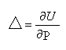
Maxwell Law of Reciprocal Deflection:-
“The deflection of a point “D” on a structure or beam due to a unit load acting at “D” is equal to the deflection at point “D” due to unit load acting at point “C”.”
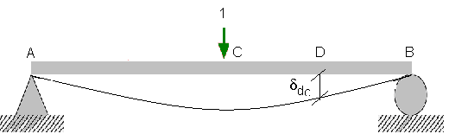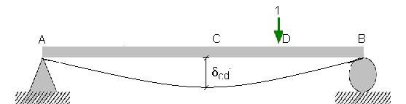
δ_{cd} = δ_{dc}
“The rotation of a point “B” on a structure or beam due to a unit couple acting at “A” is equal to the rotation at point “A” due to unit couple acting at point “A”.”
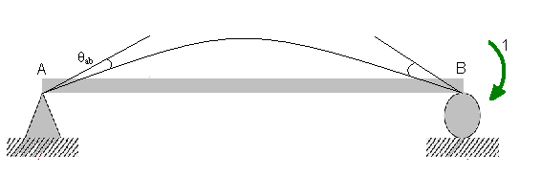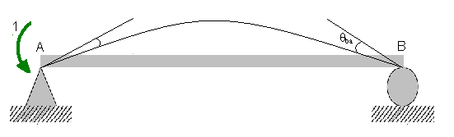
θ_{ab} = θ_{ba}
“If a unit force and a unit couple are acting at separate points on structure or beam than the rotation in radians at point “A” on a structure due to unit load acting on a beam at point “C” is equal to the deflection at point “C” when a unit couple is acting on a point “A”.”
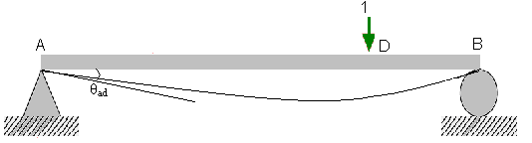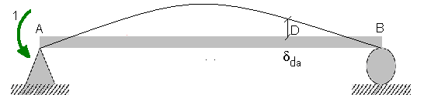

θ_{ad} = δ_{da}

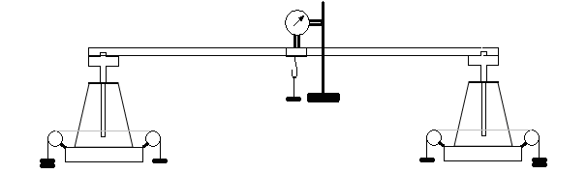

Arrangement of Apparatus

Procedure:-
- Adjust the apparatus in the frame
- Adjust the beam in the frame
- Attach the load hangers on the beam and make their load zero by setting dial gage reading to a known value
- Change the end conditions according to requirement that roller, hing or fix.
- Apply the loads on the hangers
- Note the deflection and rotation of the beam
- Note down the final reading in the observation and calculation table

Calculations of Deflections & Rotations
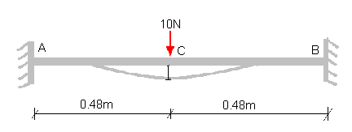
Fixed ended moments = 10 x 0.48 x 0.48² / 0.96²
= 1.2 Nm
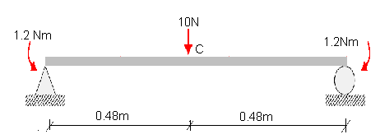
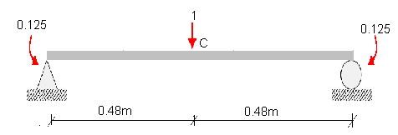
Portion Origin Limit M m
AC A 0-0.48 5 x – 1.2 0.5 x – 0.125
BC B 0-0.48 5 x – 1.2 0.5 x – 0.125

Δ = 1 / EI [₀ƒ^{0.48} (5x – 1.2)(0.5x – 0.125) dx + ₀ƒ^{0.48} (5x – 1.2)(0.5x – 0.125) dx ]

Δ = 0.04608 / EI
E = 200 GPa
I = 5.625 x 10⁻¹¹ m⁴
Δ = 4.096 mm

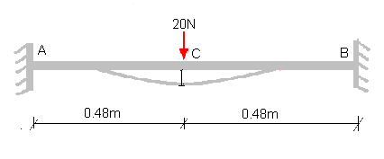
Fixed ended moments = 20 x 0.48 x 0.48² / 0.96²
= 12.4 Nm

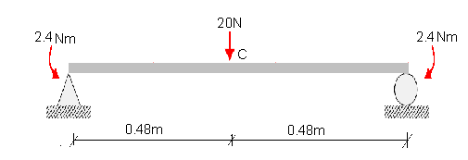

Portion Origin Limit M m
AC A 0-0.48 10 x – 2.4 0.5 x – 0.125
BC B 0-0.48 10 x – 2.4 0.5 x – 0.125

Δ = 1 / EI [₀ƒ^{0.48} (10x – 2.4)(0.5x – 0.125) dx + ₀ƒ^{0.48} (10x – 2.4)(0.5x – 0.125) dx ]

Δ = 0.09216 / EI

E = 200 GPa
I = 5.625 x 10⁻¹¹ m⁴

Δ = 8.192 mm

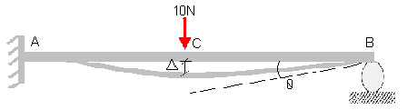

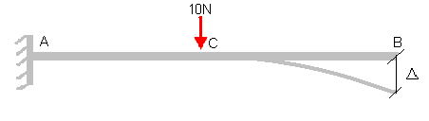
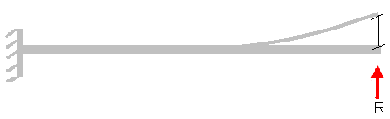
δ
Compatibility Equation

Δ = R x δ

Unit load analysis:-
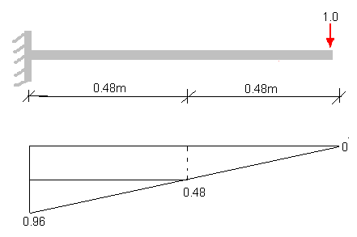
δ_{bc} = 0.48 x 0.48 x 0.24 + 0.48 x 0.48 x 0.32 / 2
= 0.09216
δ_{bb} = 0.96 x 0.96 x 0.64 / 2
= 0.294912

From compatibility equation
R = 3.125 N
By static Equations
Ra = 6.875 N
Ma = -1.8 N-m

By solving the same beam by unit load

Rb’ = 0.3125 N
Ra’ = 0.6875 N
Ma’ = -0.18 N-m

Portion Origin Limit M m
AB A 0-0.48 -1.8 + 6.875 x -0.18 + 0.6875 x
BC B 0-0.48 3.125 x 0.3125 x

By solving the above data by castiglano’s theorm

Δ = 0.08064 / EI
E = 200 x 10⁶ MPa
I = 5.625 x 10⁻¹¹ m⁴

Δ = 7.168 mm

Portion Origin Limit M m
AB A 0-0.48 -1.8 + 6.875 x 0.5-1.5625 x
BC B 0-0.48 3.125 x 1.5625 x

By solving the above data by castiglano’s theorm

θ = / EI
E = 200 GPa
I = 5.625 x 10⁻¹¹ m⁴

θ = rad

Observation & Calculation Table

Loading | LHE |  | Mid Span |  |  | RHE
Loading | DGR | Rotation ( rad) | DGR | Deflection (mm) |  | DGR | Rotation ( rad)
 |  |  |  | Exp. | Analy. | DGR | Exp. | Analy.
0 | Locked |  | 800 | 7.34 | 7.168 | 800 | 0.0248
10 (N) |  |  | 66 | 7.34 | 7.168 | 552 | 0.0248
0 | Locked |  | 1680 | 4.43 | 4.096 | Locked
10(N) |  |  | 1237 | 4.43 | 4.096
20(N) |  |  | 795 | 8.85 | 8.192

Maxwell Law of Reciprocal Deflection

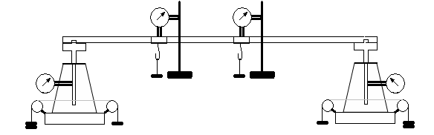

Apparatus Arrangement

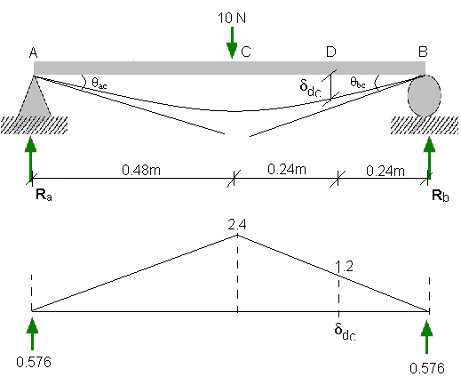

Using conjugate beam method

θ_{ac} = 0.576 / EI
= 0.0512 rad

θ_{bc} = 0.576 / EI
= 0.0512 rad

δ_{dc} = 0.576 x 0.24 – 1.2 x 0.24² /6
= 0.127 / EI
= 11.29 mm
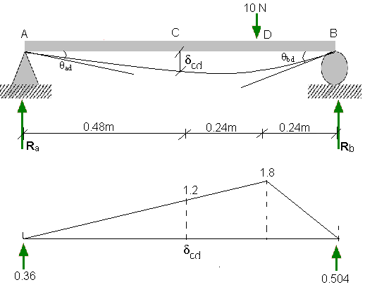
Using conjugate beam method

θ_{ad} = 0.36 / EI
= 0.032 rad

θ_{bd} = 0.504 / EI
= 0.0448 rad

δ_{cd} = 0.36 x 0.48 – 1.2 x 0.48² /6
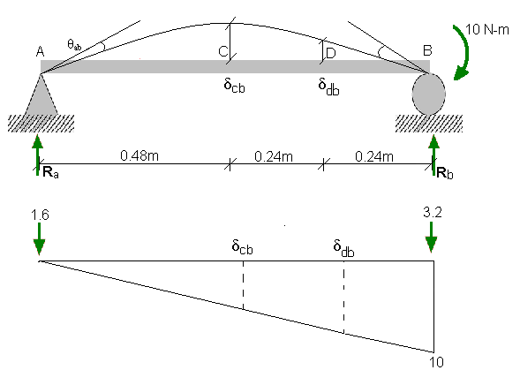
= 0.127 / EI
= 11.289 mm

Using conjugate beam method

θ_{ab} = 1600 / EI
= 0.000142 rad

δ_{cb} = 1.6 x 0.48 – 5 x 0.48² /6
= 0.576 / EI
= 0.0512 mm

δ_{db} = 1.6 x 0.72 – 7.5 x 0.72² /6
= 0.504 / EI
= 0.0448 mm

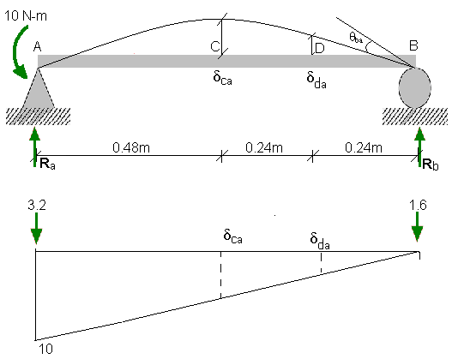

Using conjugate beam method
θ_{ba} = 16 / EI
= 0.000142 rad

δ_{ca} = 1.6 x 0.48 – 5 x 0.48² /6
= 0.576
= 0.0512 mm

δ_{da} = 1.6 x 0.24 – 2.5 x 0.24² /6
= 0.36 / EI
= 0 .032 mm

Observation & Calculation

Point | Loading | LHE |  | Mid Span |  | 3/4 Span |  | RHE
Point | Loading | DGR | Rotation  ( rad) | DGR | Deflection (mm) | DGR | Rotation ( rad) | DGR | Rotation  ( rad)
C | 0 | 1183 | 0.049 | 1670 | 15.8 | 1534 | 10.94 | 1105 | 0.037
C | 10(N) | 1678 | 0.049 | 92 | 15.8 | 440 | 10.94 | 635 | 0.037
D | 0 | 1201 | 0.028 | 1610 | 10.3 | 1489 | 8.83 | 1186 | 0.051
D | 10(N) | 1488 | 0.028 | 573 | 10.3 | 606 | 8.83 | 674 | 0.051
B | 0 | 1198 | 0.011 | 1502 | 4.8 | 1498 | 4.96 | 1090 | 0.0355
B | 10(N-m) | 1079 | 0.000073 | 1982 | 0.032 | 1994 | 0.033 | 1445 | 0.0002370
A | 0 | 1078 | 0.0283 | 1296 | 6.39 | 1563 | 3.85 | 1121 | 0.0157
A | 10(N-m) | 788 | 0.000189 | 1935 | 0.043 | 1948 | 0.026 | 1278 | 0.000105

Results:-
- δ_{cd} = δ_{dc}
- δ_{ac} = δ_{ca}
- θ_{ab} = θ_{ba}
- θ_{ad} = δ_{da}
- θ_{bc} = δc_{b}
- θ_{bd} = δ_{db}

Precautions:-
The following precautions should be taken in order to perform the experiment properly in the lab
- The beam should be properly adjusted in the frame
- The hangers should be located at the proper place
- The distance b/w the supports should be accurate
- During the performance the movement of apparatus should be avoided.
- The load should be applied slowly.
- Reading should be taken carefully

Comments:-
There is a little difference b/w the experimental and the analytical values which may be due to the following reasons
- There is the friction b/w the parts of the apparatus
- The length of the beam may not be accurate and the loads may not be hanged at the accurate position supposed
- This error may be due to reason than the supports provided may not be properly set

