Experiment # 1

To determine the reactions of a continuous beam at spot which may not constraint to rotate but may liable to settle?

Objective:-
“To compare or justify analytical and experimental results”

Apparatus:-
- Hi-Tech Universal Test Frame
“It is a steel frame in which we can make the arrangement of different
type of structure like continuous beams, frames, arches etc for
experimental study”
- Load Measuring Pier
“This load measuring pier serves as a support for the loads and
used to determine the reactions at supports.”
- A Steel Beam
  - Modulus of Elasticity “E” = 205GPa
  - Cross-sectional Dimensions = 25mm x 5mm
- Load hangers and weights
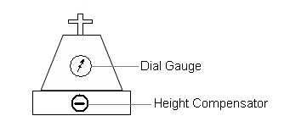
Height Compensator:-
Horizontal scale = 15 divisions
Circular scale = 100 divisions
Maximum reading = 1500 div
Dial Gauge:-
Least count = 0.1 N
Large scale = 100 divisions
Small scale = 25 divisions
Maximum Reading = 250 N

I Div. on Height Compensator = 1Div. on Dial Gauge

100 divisions on large scale

25 divisions on small scale

Related Theory

Continuous Beams:-
“Continuous beams, which are beams with more than two supports and covering more than one span, are not statically determinate using the static equilibrium laws.”

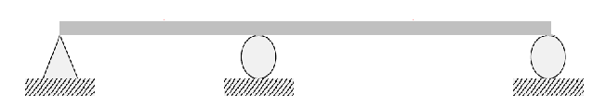
Continuous beam Propped cantilever beam

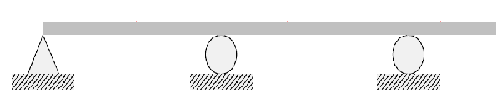
Overhanging beam

Statically Determinate Beams:-
“Beams that have three unknown support reactions and can be analyzed by the application of the basic equations of static equilibrium”
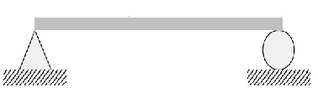
Simply supported beam Cantilever beam

Statically In-determinate Beams:-
“A structure is statically indeterminate when the static equilibrium equations are not sufficient for determining the internal forces and reactions on that structure.”

Fixed ended beam Propped cantilever beam
Continuous beam

Methods To Analyze Indeterminate Beams:-
- Force Method
- Three Moment Equation Method
- Slope Deflection Method
- Column Analogy Method
- Moment Distribution Method
- Stiffness Method

Procedure:-
- Adjust the Height Compensator in the frame
- Adjust the beam in the frame
- Attach the load hangers on the beam and make their load zero by setting the load measuring pier at the same reading
- Apply the loads on the hangers
- Note the settlement of the beam
- By rising the level of height compensator try to make the settlement zero
- Note down the final reading in the observation and calculation table

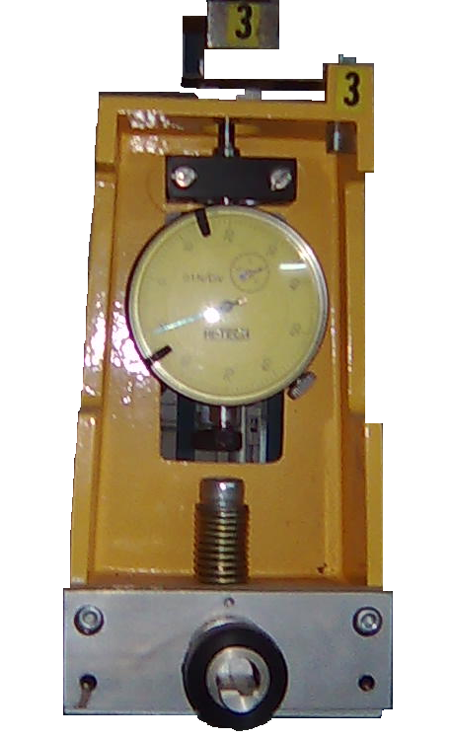

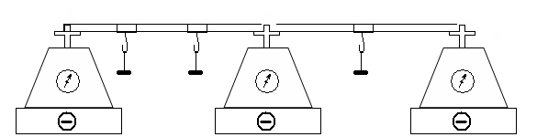

Compatibility Equations:-

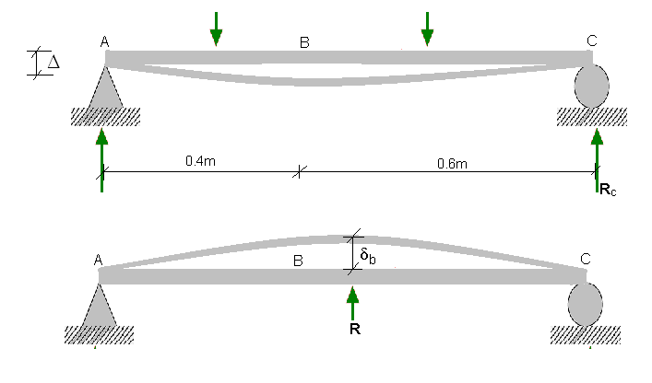

Δ = R x δb

Unit Load Calculations

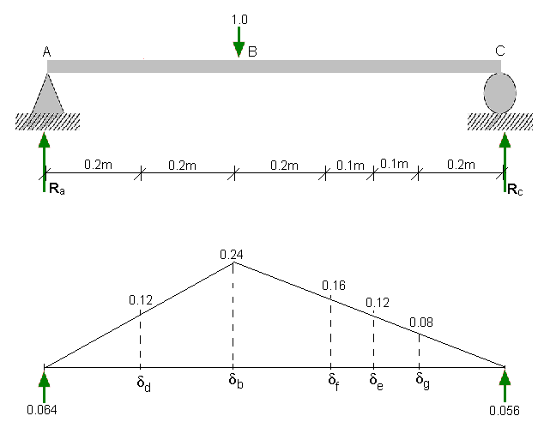

δd = 0.06 x 0.4 – 0.12 x 0.2² /6
= 0.012

δb = 0.064 x 0.4 – 0.24 x 0.4² / 6
= 0.0192

δf = 0.056 x 0.4 – 0.16 x 0.4² /6
= 0.01813

δe = 0.056 x 0.3 – 0.12 x 0.3² /6
= 0.015

δg = 0.056 x 0.2 – 0.12 x 0.2² / 6
= 0.01067

Case 1
From compatibility condition

R_{b} x 0.0192 = 15 x 0.012 + 30 x 0.015

R_{b} = 32.8125 N

By solving the beam

R_{a} = 1.3125 N

R_{c} = 10.875 N

The Shear Force & Bending Moment Diagrams are given below

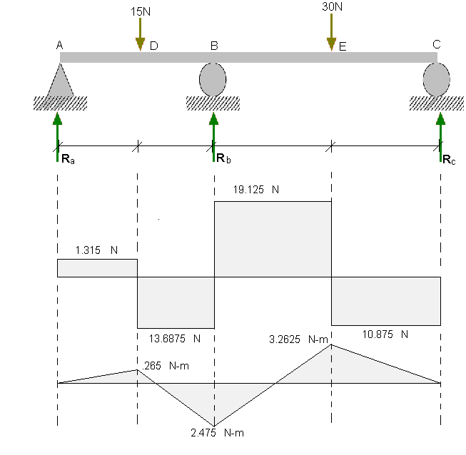

Case 2
From compatibility condition

R_{b} x 0.0192 = 15 x 0.012 + 20 x 0.01813

R_{b} = 28.26 N

By solving the beam

R_{a} = 3.04 N

R_{c} = 3.70 N

The Shear Force & Bending Moment Diagrams are given below

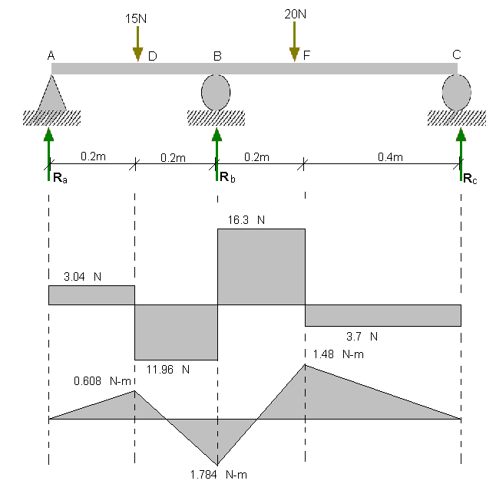
Case 3
From compatibility condition

R_{b} x 0.0192 = 25 x 0.01813 + 20 x 0.010667

R_{b} = 34.72 N

By solving the beam

R_{a} = -6.83 N

R_{c} = 17.11 N

The Shear Force & Bending Moment Diagrams are given below

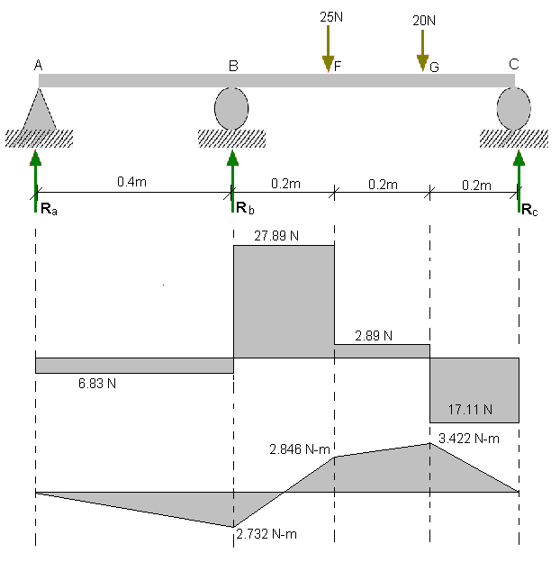

Observation & Calculation Table:-

Case 1
Support | A | B | C
Initial Reading | 500 | 500 | 500
Final Reading | 520 | 803 | 604
Difference | 20 | 303 | 104
Reaction | 2.0 | 30.3 | 10.4
Analytical | 1.3125 | 32.8125 | 10.875
Case 2
Support | A | B | C
Initial Reading | 500 | 500 | 500
Final Reading | 531 | 740 | 540
Difference | 31 | 240 | 39
Reaction | 3.1 | 24 | 3.9
Analytical | 3.04 | 28.26 | 3.7
Case 3
Support | A | B | C
Initial Reading | 500 | 500 | 500
Final Reading | 439 | 831 | 672
Difference | -61 | 331 | 172
Reaction | -6.1 | 33.1 | 17.2
analytical | -6.83 | 34.72 | 17.11

Precautions:-
The following precautions should be taken in order to perform the experiment properly in the lab
- The beam should be properly adjusted in the frame
- The hangers should be located at the proper place
- The distance b/w the supports should be accurate
- The settlement of the beam should be properly adjusted
- Reading should be taken carefully

Comments:-
There is a little difference b/w the experimental and the analytical values which may be due to the following reasons
- The apparatus may need calibration
- There is the friction b/w the parts of the apparatus
- The length of the beam may not be accurate and the loads may not be hanged at the accurate position supposed
- This error may be due to reason than we cannot have fully control over the settlement of the beam

