**Igneous Rocks**

*Igneous rocks (etymology from* [*Latin*](http://en.wikipedia.org/wiki/Latin) *ignis, fire) are formed by the cooling and solidification of magma or lava.*

Magma is a hot, viscous, silicate melt, containing gases. It comes from great depth below the earth’s surface. When magma comes out upon the earth’s surface, it is called lava.

**Mineralogy of igneous rocks**

Many different types of mineral occur in igneous rocks, but only about eight are normally present as essential constitutes of a rock. This of the eight is controlled primarily by the composition of the magma. Each mineral starts to crystallize at a particular temperature and continues to form throughout a limited temperature range as the magma cools. More than one mineral is usually forming at any one time. Since the crystals formed early have a higher specific gravity than the remaining liquid of the magma, they settle downwards. Alternatively, the two fractions, crystals and liquid, may be separated by some other process. As time progresses, different minerals crystallize from the magma. Eventually this process gives rise to a sequence of layers of minerals of different compositions, from high-temperature, high-specific gravity minerals at the bottom, to low-temperature, low-specific gravity minerals at the top. Such magma is said to be differentiated. When consolidated, the highest temperature layer of minerals at the bottom, consisting of olivine, calcium-rich plagioclase and often augite, will form an ultrabasic igneous rock, at relatively low temperatures; the last of the magmatic liquid solidifies into rock that contains quartz, orthoclase, sodium-rich plagioclase and micas. Because of its relative richness in silica, it is called an acid rock. The boundaries between four main groups of igneous composition, but they are drawn in such a way that the presence or absence of certain minerals such as quartz and olivine allows a rock to be put at the acidic or basic ends of the scale.

**Texture of igneous rocks**

Texture means the size, shape, and arrangement of mineral grains in a rock. The texture of a rock is governed by the cooling rate of the magma. In general, slower is the rate of cooling, the coarser is the grain of the rock. It is because; in slow cooling more opportunity is provided for crystals to grow to a large size. On the other hand, the glassy texture results from extremely rapid cooling. Between these two extremes there are fine grained and cryptocrystalline textures.

**Types of textures in igneous rocks**

**Phaneritic texture**

Phaneritic textured rocks are comprised of large crystals that are clearly visible to the eye with or without a hand lens or binocular microscope. The entire rock is made up of large crystals, which are generally 1/2 mm to several centimeters in size; no fine matrix material is present. This texture forms by slow cooling of magma deep underground in the plutonic environment.

http://geology.csupomona.edu/alert/igneous/phaneritic.gif**[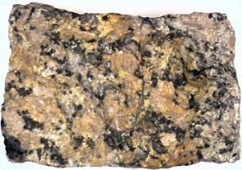](http://geology.csupomona.edu/alert/igneous/idphan.htm)**

**Aphanitic texture**

Aphanitic texture consists of small crystals that cannot be seen by the eye with or hand lens. The entire rock is made up of small crystals, which are generally less than 1/2 mm in size. This texture results from rapid cooling in volcanic or hypabyssal (shallow subsurface) environments.

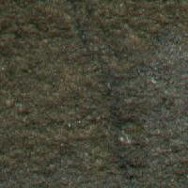**[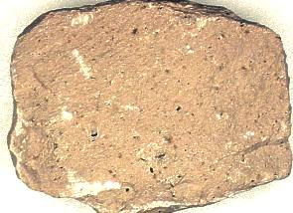](http://geology.csupomona.edu/alert/igneous/idaphan.htm)**

**Porphyritic texture**

Porphyritic texture exists where larger and smaller crystals are both present in the same rock. The smaller crystals may be of fine-, medium- or coarse-grained size and are spoken of collectively as the matrix in which the larger phenocrysts are set. The texture is found most commonly in extrusive rocks, but is also sufficiently common in some hypabyssal rocks to merit a special name (**porphyries)** for them. For example, in quartz porphyry the most common phenocryst is quartz. Porphyritic rocks are formed when a column of rising magma is cooled in two stages. In the first stage, the magma is cooled slowly deep in the crust, creating the large crystal grains, with a diameter of 2 mm or more. In the final stage, the magma is cooled rapidly at relatively shallow depth or as it erupts from a volcano, creating small grains that are usually invisible to the unaided eye.

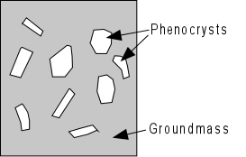

**Vesicular and amygdaloidal textures**

Vesicular and amygdaloidal textures occur most commonly in extrusive rocks. Gases dissolved in magma under the high pressers found at depth come out of solution and start to expand as the magma rises towards the surface. The gas forces the magma apart initially as a bubble within the rock, and eventually it may force its way upwards through the magma escape. In lava flow the rapid congealing of the molten rock hinders or prevents this, and the gas is trapped within the rock in cavities which are called **vesicles**. These voids in the rock are often filled with later minerals which may have been precipitated from water circulating in the rock just before, or at some time after, consolidation. A vesicle filled with mineral is called amygdale, and the rock has an amygdaloidal texture. Amygdales can be distinguished from phenocrysts because of their rounded shape and variation in amount within the rock.

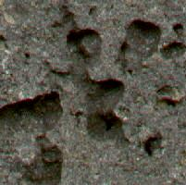**[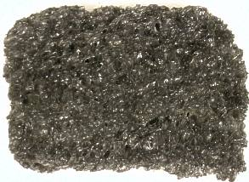](http://geology.csupomona.edu/alert/igneous/idves.htm)**

**Ophitic texture**

Ophitic texture is produced when plagioclase feldspar and augite crystallize at the same time to produce a felted arrangement of interlocking crystals. It is normally present in the basic hypabyssal rock **dolerite**, and is the reason for its high crushing strength, and hence for its suitability as roadstone.

**Pegmatitic texture**

Pegmatitic texture is produced where the concentration of water and other fluxes in the late-stage residue of magma lowers the temperature of crystallization of the minerals forming in it, allowing an individual crystal to achieve a size well beyond what is meant by coarse-grained. Pegmatitic texture characteristically occurs in veins of very acid igneous rock (**pegmatite),** which are sources of economically important minerals.

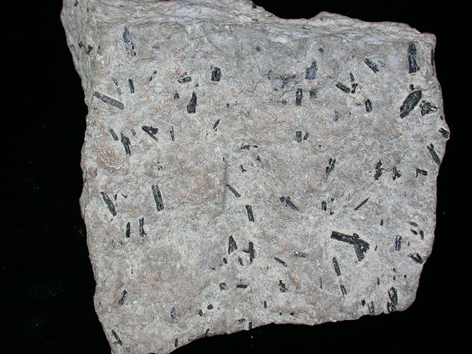

**Glassy texture**

Glassy textured igneous rocks are non-crystalline meaning the rock contains no mineral grains. Glass results from cooling that is so fast that minerals do not have a chance to crystallize. This may happen when magma or lava comes into quick contact with much cooler materials near the Earth's surface. Pure volcanic glass is known as obsidian.

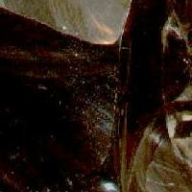**[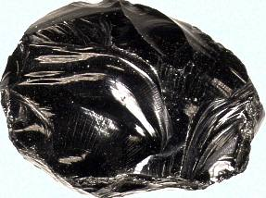](http://geology.csupomona.edu/alert/igneous/idglass.htm)**

**Classification of igneous rocks**

On the basis of texture and mode of occurrence, the igneous rocks have been classified into three groups:

1. Plutonic or Intrusive rocks
2. Volcanic or Extrusive rocks
3. Hypabyssal rocks

**Volcanic rocks**

Volcanic rocks are formed when the magma erupts at the earth’s surface and cools rapidly. The volatiles present in the magma escape into the atmosphere. The texture of such rocks are fine grained or glassy. Volcanic rocks often contain gas cavities called “*vesicles*”. These rocks sometimes show “flow structure” which is the result of movement in viscous lava. It is seen as lines or streaks of different colour in a rock.

**Plutonic rocks**

Plutonic igneous rocks have formed by the slow cooling of great volumes of magma, typically at depths of a few kilometers, within the Earth. It is erosion throughout geological time that has removed the overlying rocks and revealed these plutonic intrusions at the surface. The heat from their enormous bulk can dissipate only very slowly and they are normally coarse grained.

**Hypabyssal rocks**

Hypabyssal igneous rocks form minor intrusions which have solidified below the surface and have cooled more slowly than extrusive rocks because of the thermal insulation of the surrounding country rocks. They are typically, but not invariably, medium-grained.

**Description of igneous rocks**

**Granite**

It is a coarse-grained rock which is composed of quartz, alkali feldspar (orthoclase and microcline) and small amount of biotite or hornblende or both. The average granite contains 60% feldspars, 30%quartz, and 10% ferromagnesian minerals. The granites are mostly light in colour with a white or pink tint according to the colour of feldspar.

**Pegmatite**

The pegmatites are composed of quartz, orthoclase and muscovite. They are very coarse grained in texture and contain crystals, which are sometimes more than 30 cm across. The muscovite used commercially, is obtained from pegmatites. Pegmatites usually occur as dykes.

**Rhyolite**

Rhyolite is similar to granite in mineral composition but very different in texture. The texture is often porphyritic, which contains phenocrysts of quartz and feldspar, set in a finely crystalline or glassy groundmass. The colour of the rock is generally white, grey, or pink. Rhyolites may show flow structures.

**Obsidian**

Obsidian is a glassy rock which is acid in composition. It is generally dark colored (i.e. brown, black or red) but shows brilliant luster.

**Pumice**

It is a cellular, volcanic froth of glassy texture which is so light that it floats on water. It is formed on the surface of acid lavas.

**Diorite**

It is a coarse-grained rock which is mainly composed of plagioclase feldspar and hornblende. However, in some varieties augite and biotite mat occur. Most diorites contain little or no quartz.

**Syenite**

It is a coarse-grained rock which is mainly composed of orthoclase, soda-plagioclase and one or more mafic minerals such as biotite and hornblende. It has little or no quartze. Syenites are generally light in colour.

**Trachyte**

Trachyte is the volcanic equivalent of syenite. It has a porphyritic texture. Most trachyte-porpyries have phenocrysts of feldspars embedded in the groundmass of minute feldspar crystals.

**Gabbro**

It is a coarse grained plutonic which is dark green or black in colour. It is composed of calcite-plagioclase (labrodorite), augite (diallage), and magnetite.

**Dolerite**

The colour of dolerite is usually dark being almost black when fresh. Its texture is medium to fine grained. It is mainly composed of plagioclase, augite and iron oxide whth some olivine. Altered forms of dolerite have a dull green colour and are known as diabase. Dolerite is a hypabyssal rock which occurs chiefly in dykes and sills.

**Basalt**

Basalt is a dense looking black volcanic rock. Its texture is fine grained to glassy. It is composed of augite, plagioclase (labrodorites), and iron oxide. Basalt sometimes contains vesicles which have become filled with secondary minerals like quartz, calcite, zeolite etc. and the rock is then said to have an amygdaloidal structure.

**Peridotite**

It is a coarse grained rock of dark colour which is composed almost entirely of ferromagnesian minerals like olivine and augite. Quartz and feldspars are mostly absent.

**Pyroxenite**

It is a coarse grained rock of dark colour which is mainly composed of calcite-plagioclase, hornblende, and pyroxene (augite, hypersthenes).

**Mode of occurrence**

**Batholith**

Batholiths are large intrusive igneous bodies which are generally granitic in composition. In plan view their outline is irregular and the area of outcrop exceeds 100 square kilometers. Most batholiths increase in size with depth and they are thought to be bottomless.

**Stock and Boss**

A stock is a small batholith. Its area of outcrop is less than 100 square kilometer. A stock having a circular outcrop is called a boss.

**Lacolith**

Lacoliths are plano-convex intrusive igneous bodies which cause the overlying beds to arch in the form of a dome. A lacolith may be 2 to 3 kilometer in diameter and several hundred meters in thickness. It differs from a batholith in being much smaller and having a known floor.

**Sill**

A sill is a sheet like igneous body which runs parallel to the bedding of the enclosing rock. They may be horizontal, inclined, or vertical depending upon the attitude of the strata in which thet are intruded. Sills vary in thickness from a few centimeters to several hundred meters, but they are always thin as compared to their length along the beds.

**Dyke**

A dyke is a more or less vertical wall-like igneous body that cuts across the bedding of the country rocks. The thickness of a dyke may vary from a few centimeters to a hundred meter or more. A dyke which has a circular outcrop and a conical from is called a ring dyke. Dykes having inverted conical from and circular outcrops are described as cone sheets. Dykes probably represent a crustal fracture into which the magma was injected.

**Volcanic neck or plug**

A volcanic neck or plug is a vertical intrusion of igneous mass which has a roughly oval or circular cross-section. It represents the vent of an extinct volcano. Volcanic necks range in diameter from a few hundred meters to a kilometer.

**Lava flows**

The volcanic igneous rocks occur as lava flows. They are tabular in shape and may range in thickness from a few meters to several hundred meters. Lava flows are formed when lave breaks through the earth’s crust along fissures kilometers in length, and very large quantities of it are poured out over the land.

**Lopolith**

It is a lenticular igneous body which is bent or sagged downward into a basin like shape.

**Phacolith**

Phacoliths are intrusions of igneous rocks which occupy crests and troughs of folded strata.

