Experiment #2

Determination of reactions of continuous beam due to settlement of support

Objective:-
To study the effect of settlement of support on the structure or support
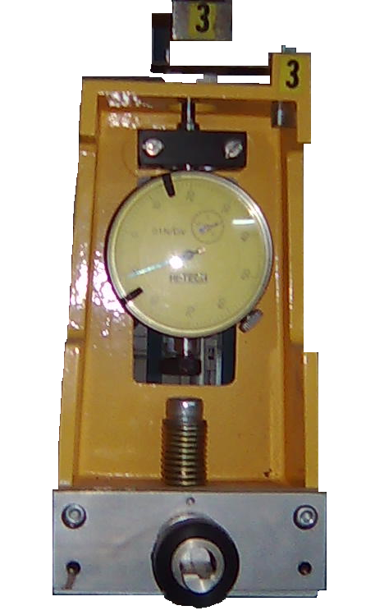
Apparatus:-
- Hi-Tech Universal Test Frame
- Deflection Gauge
- A Steel Beam
Modulus of Elasticity “E” = 205GPa
Cross-sectional Dimensions = 25mm x 5mm

Related Theory
Stiffness:-
Stiffness is the resistance of an elastic body to deformation by an applied force. It is an extensive material property

“Stiffness is the internal resistive force which is produced by unit deformation”

- The stiffness, k, of a body is a measure of the resistance offered by an elastic body to deformation (bending, stretching or compression).”
- In the International System of Units, stiffness is typically measured in Newton per meter

The Axial Stiffness is
k=EA/L
Where
A is the cross-sectional area,
E is the (tensile) elastic modulus (or Young's modulus),
L is the length of the element.
Flexural Stiffness is
K=EI/L³
Where
I is the moment of inertia
E is the (tensile) elastic modulus (or Young's modulus),
L is the length of the element
The stiffness depends upon
- Material properties
- Geo-metrical properties

Flexibility:-
“It is defined as the stiffness produced by unit force”
It is the reciprocal of stiffness and is given as

Flexibility = 1 / stiffness
f = 1 / k
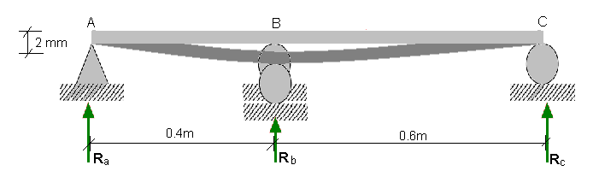

Procedure:-
- Adjust the Height Compensator in the frame
- Adjust the beam in the frame
- Attach the load hangers on the beam and make their load zero by setting the load measuring pier at the same reading
- Apply the known settlement in the beam
- Note the settlement of the beam
- By rising the level of height compensator try to make the settlement zero at the ends
- Note down the final reading in the observation and calculation table
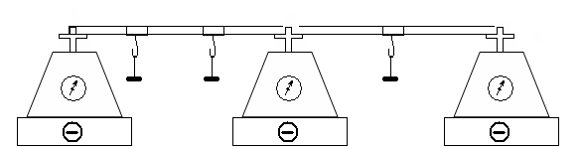

Compatibility Equations:-

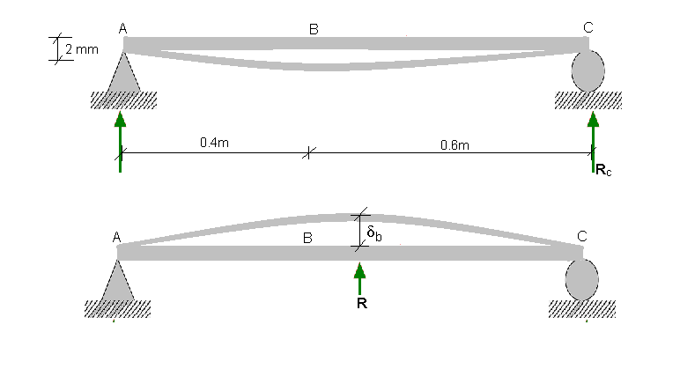

0.2mm = R X δb

Unit Load Calculations

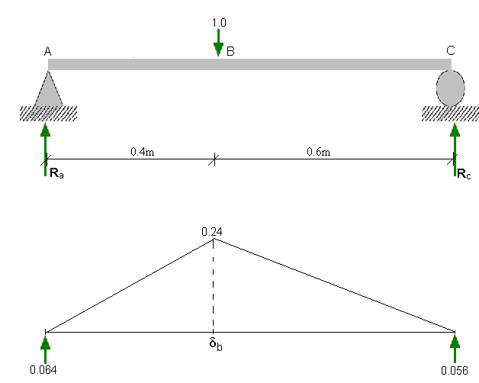

δb = 0.064 x 0.4 – 0.24 x 0.4² / 6
= 0.0192

From compatibility condition

R_{b} x 0.0192 / EI = 0.002 m

R_{b} = 5.56 N

By solving the beam

R_{a} = -3.336 N

R_{c} = -2.224 N

The Shear Force & Bending Moment Diagrams are given below
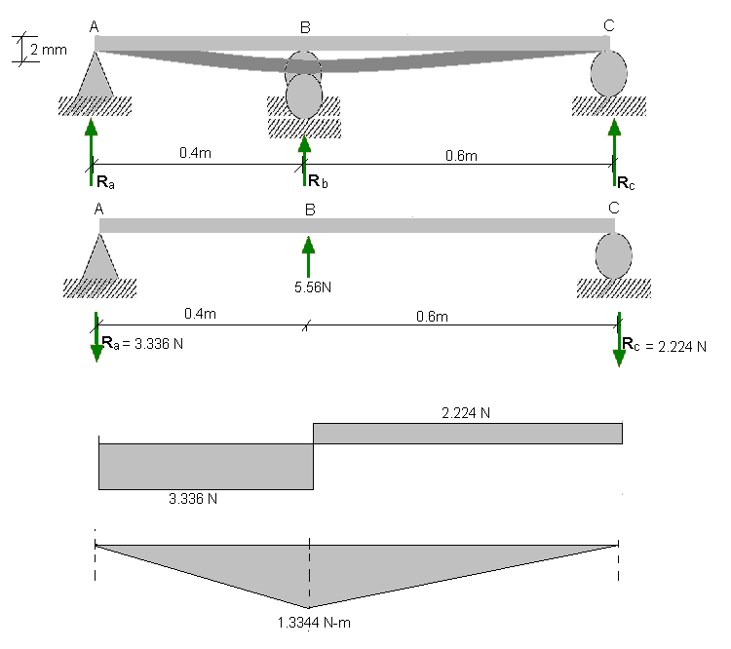

Observation & Calculation Table:-

Support | A | B | C
Initial Reading | 100 | 100 | 100
Final Reading | 72 | 154 | 81
Difference | -28 | 54 | -19
Reaction | -2.8 | 5.4 | -1.9
Analytical | -3.666 | 5.56 | -2.224

Comments:-
There is a little difference b/w the experimental and the analytical values which may be due to the following reasons
- The apparatus may need calibration
- There is the friction b/w the parts of the apparatus
- The length of the beam may not be accurate and the loads may not be hanged at the accurate position supposed
- This error may be due to reason than we cannot have fully control over the settlement of the beam

