Basics of Structural Geology

First of all we need to understand how rocks deform?

**MODES OF DEFORMATION OF ROCKS**

* Within the Earth, rocks are continually being subjected to forces that tend to bend them, twist them, or fracture them.
* When rocks bend, twist or fracture we say that they deform (change shape or size).
* The forces that cause deformation of rock are referred to as stresses (Force/unit area). So, to understand rock deformation we must first explore these forces or stresses.

**Stress and Strain**

* Stress is a force applied over an area. One type of stress that we are all used to is a uniform stress, called pressure.
* A uniform stress is a stress wherein the forces act equally from all directions. In the Earth the pressure due to the weight of overlying rocks is a uniform stress, and is sometimes referred to as confining stress.
* 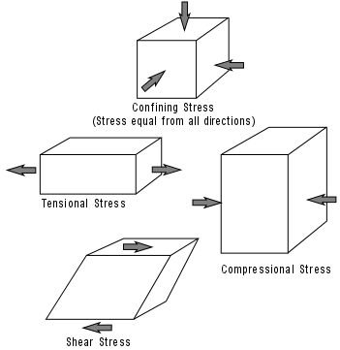When rocks deform they are said to be in strain.
* A strain is a change in size, shape, or volume of a material.

**Differential Stress**

* If stress is not equal from all directions then we say that the stress is a differential stress. Three kinds of differential stress occur.
* **Tensional stress (or extensional stress),** which stretches rock;
* **Compressional stress**, which squeezes rock;
* **Shear stress**, which result in slippage and translation.

**Stages of Deformation**

* When a rock is subjected to increasing stress it passes through 3 successive stages of deformation.
* **Elastic Deformation** -- wherein the strain is reversible.
* **Ductile Deformation** -- wherein the strain is irreversible.
* **Fracture - irreversible strain--** wherein the material breaks.
* We can divide materials into two classes that depend on their relative behavior under stress.
* **Brittle materials** have a small or large region of elastic behavior but only a small region of ductile behavior before they fracture.
* **Ductile materials** have a small region of elastic behavior and a large region of ductile behavior before they fracture.

