CHAPTER 11 DESIGN AND SUPPORT OF TUNNELS: OPERATIONAL CRITERIA AND PRINCIPAL SUPPORT TYPES
Introduction
When a tunnel is excavated in all but the most competent of ground conditions it is an inevitable consequence that some form of support will be required if the tunnel is to retain adequate stability and/or maintain sufficient dimensions to facilitate its use in the intended manner.
The form and function of the support will vary according to a wide range of factors apart from just geotechnical considerations and it would seem that for every different tunnel there is a different lining solution [11.1].
Tunnel linings: main types. Tunnel linings are grouped into three main forms some or all of which may be used in the construction of a tunnel:
- Temporary ground support
- Primary lining
- Secondary lining [11.2]
Temporary ground support. In rock tunnels where the ground has insufficient stand-up time to allow the construction of the primary lining some distance behind the face, then some form of temporary ground support applied at the- tunnel face is required eg rock bolts, shotcrete and steel sets.
Such support is not required in soft ground in conjunction with a shield driven tunnel as temporary ground support is provided by the body of the shield itself.
Primary lining. A primary lining is the main structural component of the tunnel support system which is required to sustain the loads and deformations that the ground may induce during the tunnel's intended working life. A further function performed by the primary lining is the control of water egress (exit) and ingress (entrance).
Secondary lining. Various tunnels require smooth bore profiles for their intended use, eg sewer and water tunnels or aesthetic finishes for public usage, eg highway and pedestrian tunnels. Erosion and corrosion protection for the primary lining and further waterproofing may also be required, all of which are provided by secondary linings.
The terms temporary, primary and secondary linings are not always defined on a consistent basis in various texts [11.3].
Requirements for tunnels
Prior to the discussion of support types and design principles it is important to differentiate between the two very different areas of application of tunnelling, namely civil and mining engineering together with the relative support requirements in each of these categories.
Civil engineering tunnels
Tunnels in the civil engineering category are generally driven at relatively shallow depths by comparison to those situations involving mining tunnels.
Civil engineering tunnels require higher tolerances in terms of the final tunnel profile and its ensuing stability.
Many civil engineering tunnels relate to public usage and high density traffic with projected working lives in excess of 100 years.
As a result, long term stability is desired coupled with an appropriately high factor of safety (>2.0).
Other factors which are critical to the design and use of civil engineering tunnels include line, grade, special surface finishes and prevention of water inflow or outflow in respect of the tunnel structure.
Mining engineering tunnels
Mining engineering tunnels’ function is to provide access to the workings for men, materials and ventilation in addition to egress for men and the mined minerals/rock products.
In general, the traffic using mining tunnels is of relatively low density whilst the projected working lifetime is relatively short when compared to civil engineering tunnel applications with perhaps the exception of mine shafts.
It is only the major tunnels in mining situations which need to be maintained open for the full life of the mine, whereas the majority of mining tunnels which are associated with mineral exploitation may only need to remain functional for a period of time of generally less than 10 years.
As a result, the acceptable levels of deterioration and deformations for mine tunnels are higher than civil engineering tunnels and also any repair work is far easier to facilitate.
The use of secondary linings is also precluded (omitted) as aesthetics is not a consideration for mine tunnels.
In general, the function of a mine tunnel support is simply to keep the tunnel adequately stable and/or open to a sufficient size thus allowing the mining operation to take place relatively unhindered in an acceptable condition of safety, typical factors of safety being 1.2-1.5.
It is clear then that the roles of civil and mining engineering tunnels are very much different in many aspects and this leads to different philosophies in terms of formulating acceptable support designs.
Although, the methods used in arriving at the final designs may be similar in both fields, the interpretation of the results will be quite different.
Therefore, both approaches are worthy of separate explanation.

Civil Engineering Tunnels: Design Considerations
Civil engineering tunnels are constructed in the full spectrum of possible ground conditions ranging from soft ground to massive unjointed rock, coupled with various states of in situ stress and hydrogeology (Table 11.2).
However, the dimensions and details of a tunnel lining for civil engineering purposes are rarely governed only by geotechnical considerations and the loads and deformations that will be imposed on the lining [11.4].
The user needs are the only real basis for constructing a tunnel and that the designer should first consult the user or client commissioning the tunnel construction [11.3].
This is due to the fact that the user may require certain aspects to be a part of the tunnel design, eg conformation to an existing tunnelling system, intended service life and the reduction of capital outlays by accepting higher levels of maintenance.
Water. Given that the requirements of the user are established, the first consideration in designing a tunnel lining is that of water. If the lining has to resist hydrostatic pressures either externally or internaily then this will in general govern the lining design and control the success of the tunnelling operation [11.4].
A tunnel specification will often state that it should be completely dry for its intended operation, but such a condition may not be economically feasible. Therefore, consideration should be given to the tunnel's intended use and its sensitivity to water leakage either in or out of the tunnel. O'Rourke [11.3] summarises a number of considerations which should be taken into account regarding water infiltration into various types of tunnel, these being presented in Table 11.3.

Table 11.2 Ground classification in relation to tunnel design [11.2]

Classification | Uniaxial compressive strength (MPa) | Ground types
Soft ground |  | (a) Recent alluvium and glacial drift depositsincluding water-bearing sands, gravels, silts, and clays, and boulder clay.  (b) Eocene, Cretaceous and Jurassic stiff fissured clays
Very weak to moderately strong rock | up to 50 | Low strength rocks including shales, Cretaceous Chalk, Triassic (Keuper) Marl and Jurassic rock formations.
Strong rock | 50-100 | Many Triassic and Permian rock formations,  sandstones and medium strength Carboniferous Coal Measures.
Very strong and extremely strong rock | above 100 | The hard Carboniferous and older rocks, the limestones and harder rocks.

Table 11.3 Summary of infiltration considerations for several types of tunnel [11.3]

Tunnel type | Considerations regarding tunnel infiltration
Rapid transit | Need to evaluate corrosion. Deterioration possible for rails, track fasteners, wooden ties, train control and signalling equipment, metallic fixtures, electrical installations, and reinforced concrete. Initial costs of leakage control must be evaluated relative to long term maintenance.
Subway stations, pedestrian walkways | Avoid wet patches. Intercept (stop) drips on walking surfaces. Promote clean surfaces. Strict limits imposed on discoloration and dulling of surface finishes.
Highway | Need to minimise traffic hazards. Promote clear visibility and clean surfaces. Avoid freezing. Some water introduced by vehicles and periodic spraying to wash internal surfaces. Drainage system capacity usually governed by fire-fighting water criteria.
Water conveyance | Infiltration rates for waste-water tunnels often set byfederal and state regulations. During periods of high flow, tunnels may be affected by internal pressure. Exfiltration should be evaluated under conditions of internal pressures.
Cable | Temporary leakage control necessary when joining cables. Permissible rates of infiltration often larger for the invert than for the crown.

There are various methods available to facilitate the waterproofing of a tunnel varying from simple caulking or sealing of the longitudinal and radial joints of the lining to the installation of a full waterproof membrane between either the temporary and primary or primary and secondary linings. Any water trapped behind the lining as a result of such measures is then channelled away. The most common method is that of joint sealing which will inevitably not achieve a completely dry tunnel but may reduce the water inflows to acceptable levels. Table 11.4 gives a summary of various UK tunnels and the infiltration rates in conjunction with the ground conditions and applied support system. It is clear from Table 11.4 that a bolted cast iron lining gives better waterproofing than a bolted concrete lining in similar conditions. This is a result of cast iron linings lending themselves to sealing and not suffering further cracking during handling and construction [11.2]. The use of up to date sealing compounds, however, may partially alleviate this situation.
The design of tunnels subjected to internal water pressures is a different concept altogether as in many instances no leakages can be tolerated due to the very high pressures in the tunnel and the disastrous effects that leakage may cause to the surrounding environment. In such cases the tunnel can be made completely impervious by the use of a steel lining backfilled with concrete. In less severe cases where the internal pressure is reduced, measures include increasing the modulus of the rock mass by rock reinforcement thus enhancing its resistance to internal pressure, or pressure grouting behind the concrete lining to increase the external pressure opposing the internal pressure. Both techniques effectively reduce the likelihood of the lining cracking and causing water loss
Constructability. The next consideration in the design of a tunnel lining is constructability or its inter-relationship with the tunnelling method to be employed to drive the tunnel [11.4]. In soft ground conditions where a shield driven tunnel is required, some form of segmental lining will be required, either bolted or unbolted. Conversely, if the tunnel has an' appreciable stand-up time allowing dispensing of the tunnelling shield, then the use of a temporary support such as shotcrete followed by either a poured or precast concrete primary lining may be appropriate. In ground with good stand-up times, ribs and lagging or rockbolting can be used as the temporary support followed by a cast in situ primary concrete lining. Thus the choice of lining type may well be made prior to any considerations concerning the likely ground conditions.
Constructability of the lining may also determine the dimensions and type of lining selected. Factors such as handling and erection, jacking loads from the tunnel shield and joint details will all impose certain conditions on the dimensions of the tunnel lining for pre-cast concrete segments which as previously stated may well exceed the applied loading due to the ground conditions. Similar restrictions also apply to the application of shotcrete with respect to the maximum layer thickness that can be applied without inducing sagging from overhead surfaces and rockbolts with regard to their diameter such that they do not buckle when forced into the hole. One exception to this rule is the use of steel sets which in general are not affected by constructability considerations [11.4].
Tunnel usage. The final consideration applied to lining selection prior to geotechnical design is that of the tunnel usage [11.4], or operational criteria [11.3]. Table 11.1 has previously outlined various physical requirements of civil engineering tunnels and each of these will result in some restriction on the lining design. For example, a water transport tunnel requires a lining with good hydraulic efficiency characteristics, thus leading to choice of a smooth bore lining. Similarly, pedestrian and highway tunnels require aesthetic, durable finishes which may facilitate the need for a secondary lining.

Geotechnical Design Considerations
It is evident that the type and dimensions of a tunnel lining in the majority of civil engineering tunnels will be decided upon by the aforementioned factors prior to any consideration being given to the geotechnical environment. That is not to say that lining design in relation to the anticipated ground behaviour, and the resultant loads and deformations of the support, is not a requirement as indeed it is. This is especially the case in the present-day environment of client-contractor partnerships and the implicit legal and liability aspects.
The particulars of lining design methods for both soft ground and rock conditions are discussed in the following chapters, but the philosophy and logic behind lining design as considered by O'Rourke [11.3] and Kuesel [11.4] is referred to here as a preliminary overview of the general problems and their treatment.
The first point to be established is that the design of a tunnel lining cannot be considered as a structure being subjected to weil-defined values of loading as there is no absolute certainty of the actual ground behaviour following excavation. Thus, the problem should be considered as one related to ground and structural behaviour rather than simply one governed entirely by structural features.
The behaviour of a tunnel lining has been likened to the loading of a balloon where by the action of inward deformation results in potential outward deformation at other points around the periphery as illustrated by Figure 11.2(a). Such action mobilises the passive pressure of the surrounding ground due to its resistance to the support outward movement, providing that no voids are left at the ground-lining interface. Therefore, it is essential to perform effective contact grouting around the tunnel periphery in order to fully benefit from the above mechanism. The non-uniform stress field in the ground is redistributed to give a more uniform stress field on the flexible lining which in turn reduces the induced moments in the lining [11.3]. This only applies to closed supports with circular and elliptical profiles rather than to open supports such as arch profiles without inverts or rock reinforcement techniques. It is necessary for the support to possess a degree of flexibility since if the lining was completely rigid, then no passive earth pressures would be generated and the original non-uniform stress condition would remain around the opening with resultant bending moments in the lining as illustrated in Figure 11.2(b).
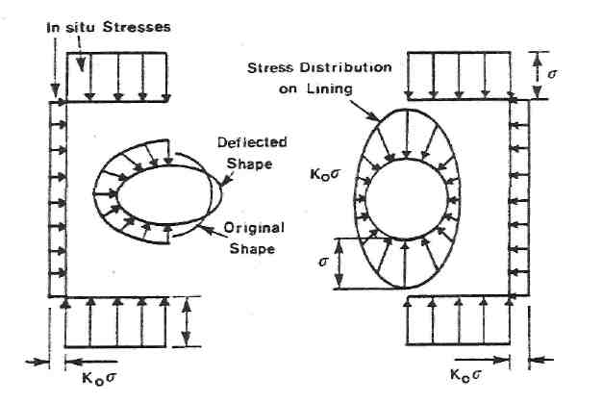
(a) Flexible lining (b) Rigid lining
k_{o} = Coefficient of horizontal earth pressure at rest
Figure 11.2 Stress distributions and deflected shapes of rigid and flexible circular linings,
after O'Rourke [11.3]
The two lining properties which affect the generation of passive earth pressures are axial stiffness and flexural stiffness. Kuesel [11.4] states that axial stiffness is much more important to a lining than flexural stiffness as increasing axial stiffness improves the efficiency of the compressive bulging action. Flexural stiffness, however, must also be of relevance as it is only by the deformation of the lining that earth pressures are generated, and a lining with an infinite flexural stiffness, ie rigid, would not deform at all.
A third factor which until recently was not a general consideration in lining design is the amount of stress relief and redistribution and consequent ground movement that occurs prior to support placement, and is known as the 'head-end effect'. The major implication of the head-end effect is that a support installed at a distance behind the face will not be subjected to the full loading and deformation as a result of the full overburden pressure. In fact, even if the support is installed at the face, a degree of stress relief and movement will have already taken place in the immediate ground in front of the face, see Figure 11.3. It is desirable to take account of the head-end effect in lining design, for economic reasons, as it will result in a support which is more correctly matched to the expected ground behaviour rather than one which is over-designed if the full overburden pressure is considered. The main problem in such an analysis, however, is in calculating the amount of stress relief at the point of support installation and the result of over-estimating this effect may lead to false conclusions concerning the stability of the support in question.
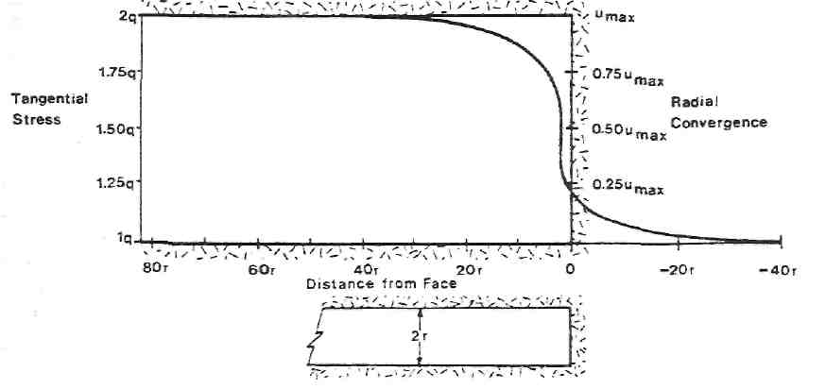
Figure 11.3 Radial convergence and tangential stress in vicinity of tunnel face, after Muir Wood [11.5] Where q = in situ hydrostatic stress

Peck [11.6] illustrates this concept graphically and comments on the design practice of reducing the applied overburden pressure in soft ground conditions and remarks that due to the lack of adequate knowledge concerning this effect, design should still be performed using the full overburden pressure. This represents the limiting condition and such an assumption will not lead to an increase in the optimum support cross-section for the practical reasons previously discussed. In rock conditions, this concept which is commonly known as the 'convergence-confinement technique' has found widespread use whereby the deformation of the rock mass prior to temporary or permanent support installation is seen as beneficial in terms of reducing the stress environment at the point of support erection and also the mobilisation of the shear strength of the ground. This philosophy is the fundamental basis of what is known as the New Austrian Tunnelling Method (NATM) [11.7].
When considering the aim of tunnel lining design analysis with respect to geotechnical loading, it is important to define that which ultimately causes failure of the fining as this forms the main purpose of the design. Kuesel [11.4] points out that there has been much analysis of tunnel linings and loading in terms of stresses and without doubt it is not lining stress that induces failure but the magnitude of deformation that the lining is forced to undergo. The main priority of the lining design, therefore, is to compute the expected deformations of the lining in order to arrive at a conclusion concerning its stability. Nevertheless, such analysis will require that the ground and lining stresses are also computed as these two aspects are mutally dependent and the accuracy to compute one will determine the accuracy relating to the other.
Common Support Types used in Civil Engineering Tunnels
As a result of the requirements of civil engineering tunnels and the ground conditions in which they are generally constructed, there are a number of standard types of supports suited to such tunnelling applications. Table 11.5 summarises the use of supports in civil engineering tunnels in various ground conditions and includes comments on their various operational features.

Table 11.5 Summary of main support types employed in civil engineering tunnels Based on.Tough and Noskiewicz [11.1], Craig and Muir Wood [11.2], O'Rourke [11.3]
and Rabcewicz [11.8].
Lining type Field of application Operational features
- Natural Good quality rock in low Surface sealants may be required
Support stress conditions in relation to prevent-drying and slabbing of rock
in rock to rock strength surfaces
- Rock 1. Untensioned bolts suitable 1. Mechanical anchored bolts liable to reinforce- for good quality rock conditions. be rendered completely ineffective by
ment 2.Tensioned bolts improve bolt failure.
effectiveness. 2. Column bonded bolts such as resin
3. Mechanical anchors require anchors can sustain bolt failure but
competent ground for suitable still remain effective.
anchorage. 3. No visual indication of failure is
4. Cement and resin anchors are given as is common with other
suitable to weak ground. support types.
5. This support type often used 4. In certain situations it can also be
in conjunction with mesh in difficult to incorporate bolting
friable rock and shotcrete operations within the tunnel drivage
as a temporary support. cycle without causing drivage delays.
6. Various bolt mediums are
available including wood dowels,
wire cables and steel.
3. Shotcrete 1. Commonly used in conjunction 1 . Application of shotcrete is
with rock bolts and mesh as a dependent upon skill of the nozzle
temporary support system in operator.
rock tunnels where a concrete 2. Steel fibre additive has been
lining cast in situ is to used as developed to improve tensile and
the primary support. shear strengths of shotcrete.
2. Used to seal off rock surfaces 3. Shotcrete rebound can be a
and prevent spalling and problem in certain conditions and
slabbing of weakened and loose under particular forms of application
rock. with some types of shotcrete.
4. Lends itself to tunnelling by drill
and blast or roadheader forms of tunnel excavation but not with full-face TBMs.
4. Standing 1. Adaptable to a wide range of 1 . Relatively lightweight by
supports: rock and soil conditions and comparison to concrete segments.
steel types tunnel profiles. 2. Failure is mainly due to plastic
- Used as temporary support hinge formation and out-of-plane which can be encased with movement in the axial direction. concrete poured in situ to 3. Performance of support is affected form a primary lining. by rib type connecting plates, axial
- Equally strong in tension and spaces or struts and blocking of compression. support legs on soft floors.
4. Rigid and yielding types are available.
5. Segmental 1. Constructed of either cast 1. Bolted linings erected in the tail of
supports iron, steel or concrete the shield and subsequently grouted.
(flexible) (reinforced) for a wide variety 2. Expanded, unbolted linings find use
of soil conditions.
Table 11.5 (continued)
Lining type Field of application Operational features
in self supporting clays eg, London
- Limited to circular profiles Clay, and do not require a shield tail. (and similar shapes) as they 3, Unbolted segmental rings with are very often used behind grouting are suitable for some rock tunnelling machines. tunnels,
- Steel linings are relatively a. Cast iron has good water sealing rare in the UK due to the cost of properties compared with concrete, steel and corrosion problems, 5, Concrete is relatively weak in although such supports are tension compared to compression, quite common in the US. 6. Concrete possesses cost advantages
over cast iron.
6. Monolithic 1. Generally used as primary 1. Thickness of lining generally
concrete linings in rock tunnels or as governed by the clearance between
supports secondary linings in soft ground, the existing support system and the
(rigid) 2. Normally erected after interior form required in the placing
significant stress relaxation as of the concrete,
under full loading, bending 2. Sufficient space needs to be
moments in the structure will provided to permit the concrete to
be significant due to its rigidity flow from the slick line in the crown
3. Generally applied over some to all locations between the form and
temporary or primary support tunnel profile.
systems. 3. Bending moments are the over-
4. Possesses good hydraulic and riding consideration in the design of a
leakage control characteristics, rigid lining.
4. Tendency is for rigid concrete linings to fail in shear rather than pure bending [11.8]. 5. Applicable to large and irregular shaped excavations.
7. Precast 1. Suited to relatively short 1. Difficult to keep in line and main-
concrete pipes lengths of tunnel (generally tain levels, especially where it is
for jacking < 450 m) of small diameter, difficult to cut an accurate profile.
1-2-5 m in soft ground/weak 2. Boulders in the ground tend to be
rock. problematical.
- Jacking pressures should be 3. Smooth extrados required for a consideration in the design. sliding purposes.
- Also used for under-ringing 4. Lubrication with bentonite is quite of existing support systems in common.
conjunction with backfilling. 5. Immediate roof support reduces
surface settlements.
8.Wood 1 .Traditional material used in 1. Limited service life and today,
supports conjunction with brickwork economics that it only finds limited
or concrete in US on a limited use in tunnelling.
scale. 2. Development of small diameter
- Used as temporary face tunnelling techniques have eliminated support in certain conditions, its use in timber headings for urban or as a temporary support area tunnelling employing small prior to primary lining in UK. diameters.
- Common early support prior
to alternative support medium.
Mining Engineering Tunnels
Design considerations. Mine tunnels can be categorised into short- and long-term tunnels according to their duty in the operation of the mine. Long-term tunnels are required to remain operative for the projected mine life and they include the shaft system either inclined or vertical, all shaft station workings and the major access tunnels extending to the boundaries of the mineral rights. Short-term tunnels are associated in general with the exploitation of the mineral and they may be only required for a few years. As such the support systems can vary quite markedly as well as the acceptable levels of deformation in the tunnels.

Mining legislation. The first consideration in the design of a mine tunnel support system should be legislation as this generally specifies the basic support requirements especially in the UK coal mining industry. Examples of such laws include designated, supports, maximum distance of erection from the tunnel face and maximum support spacings. Deviations from such rules require an exemption granted by the Mines Inspectorate. Similarly, mining tradition should also be considered as this is still very strong in the mining industry.
Using the support classification scheme developed for civil engineering tunnels, namely that of temporary, primary and secondary linings, mine tunnel supports will generally come under the heading of primary linings. Temporary support measures are not commonplace in mining industry tunnels as mining legislation requires that the supports be placed within a specified distance of the face and it is normally required that mine tunnels are supported in a single lining operation. Similarly, secondary linings are not used for aesthetic purposes as this is not a mining requirement and even though a secondary lining would improve the flow characteristics of the ventilation. The cost of a secondary lining far outweighs such an advantage in most mining tunnel situations although special consideration is given to the surface finish of mine shafts.
Cost. The overall cost is a major' consideration in the support of mine tunnels as it is essential that mining operations can be fully justified on an economic basis. Very often, the margin between economic and uneconomic is quite small. Therefore, it is essential that all items of the mine are optimised in terms of cost and due consideration taken in conjunction with their intended use. In terms of support, it is required that they facilitate the normal mining operation to proceed in a suitably safe environment. In general, the major cost of tunnel linings in mines is not necessarily their initial capital cost but indeed the. cost of subsequent repair work should it be required and this can be several times the initial cos: of drivage per unit length of tunnel. This brings into perspective the role of tunnel lining design in ensuring that as far as possible the repair work, if required, is kept to an absolute minimum if not completely eliminated, whilst still retaining an acceptable level of economics in the initial support design.
Water. The major support considerations in civil engineering tunnels have already been stated as water, constructability and usage. In mining tunnels except for shafts, major water inflows are rarely a design consideration although minor inflows are relatively common. In shaft design, however, water inflows are always a consideration as major aquifer horizons are generally encountered and the control of large water inflows at this stage influences whether the mine will be productive, economic or otherwise. Ground freezing and grouting are common water control techniques in shaft sinking in conjunction with cast iron tubbing or monolithic cast in situ concrete linings.
Constructability. The constructability of a tunnel lining in civil engineering considers its inter-relationship with the tunnelling method, ground conditions and handling procedures. In mining, access to the face is generally much easier as full-face TBM driven tunnels are rare, so that even in ground with a relatively short stand-up time, the supports can be erected/installed at the face as required by law (UK coal mining situations). With reference to the loads imposed by handling procedures, the majority of mine supports are non-concrete and less bulky which makes them relatively lighter and easier to handle. As a result, handling load is not generally a design consideration.
Tunnel usage. In mining, tunnel usage normally relates to its position with respect to the mined out areas. Major access tunnels or long-term tunnels are generally remote from the mined out areas or positioned such that the effects of mining are minimal. Short-term tunnels such as gate roadways in coal mines and cross-cuts in hard rock mines are by definition adjacent, or very close, to the mining operations and as such become subject to live stress changes as a result of the extraction of large amounts of mineral. These stresses can cause high closures and significant instability in the tunnels and their design with respect to support and repair work needs careful consideration.
Geotechnical design. Consideration of geotechnical design in mining as compared to that adopted in civil engineering, is still a relatively recent innovation, as Muir Wood [11.5] states "the practical construction of mines and tunnels sufficiently stable for their purposes preceded any supporting theory". This may imply that geotechnical design is superfluous to mine tunnel design. As mines have proceeded deeper, however, and into more severe geological conditions it has become necessary to be able to predict support behaviour prior to mining on grounds of economy and safety. Likewise, economic considerations have led to the evolution of design methods for support optimisation.
The ground conditions encountered in mining and civil engineering tunnels are generally quite different. Mining tunnels are not often driven in unconsolidated/soft ground although weak rock conditions are quite common. Also, the depth of working of mining tunnels usually far exceeds that of civil engineering tunnels. The deepest hard rock mines in the world are encountered in the South African gold mines of the Witwatersrand operating at depths as great as 4,000 m below the surface. In the UK, the deepest coal mines exceed 1,000 m. An important feature is that the effect of depth is relative to rock strength, and consequently rock failure in weak rock situations may be more pronounced at appreciably shallower depths than for stronger rock conditions at greater depths.
In situ stress. Owing to the depth of the mine workings, the openings are subjected to the effects of the tectonic stress field rather than that simply due to the weight of the overlying rock [11.5]. Where the major and minor principal stresses (σ₁ and σ₃) may be horizontal with the intermediate principal stress (σ₂) being the vertical component. This is in direct contrast to the situation closer to the earth's surface where the major principal stress is the vertical component and the horizontal component of stress is defined by a constant ratio K of the vertical component. This is independent of direction, typical values of K being less than unity although in overconsolidated clays, K may well be in the range 2-3 especially in respect of London Clay.
The effect of the higher rock stress in mining tunnels and the different principal stress conditions is to cause failure of rock surrounding the excavation and thus result in detrimental stability effects. The weak rock types such as UK Coal Measures result in such failures which are progressive and cause large plastic deformations which occur in the long-term and these can significantly reduce the tunnel's dimensions and restrict tunnel access. In hard rock mines at appreciable depths, the failure is brittle and generally more rapid. This can give rise to the phenomenon of rockbursts which are highly destructive to both equipment and human life. In addition, the presence of mining induced live stresses can significantly increase these occurrences.
Thus, the main objective of geotechnical design in mine tunnels is to predict potential failure of the surrounding rocks according to the in situ stresses, and to assess the possible form that the failure may take. From such an assessment it follows that to implement a mining support system which meets the requirements of the tunnel's designed life and with due consideration to minimising cost, then such a system should allow control of the predicted conditions with an adequate factor of safety and conform to mining legislation requirements.
Common Support Types used in Mining Engineering Tunnels
From the earliest days of mining until the middle of the 20th Century timber was the standard supporting medium due to its abundant availability and attractive strength and load-deformation characteristics. Traditionally, timber has been employed extensively for support in coal mines even at shallow depths as roof support is required owing to the weakness of the rocks associated with the Coal Measures. in hard rock mines, however, this has not always been the case as the stronger rock types often provide safe, self-supporting tunnels particularly in shallow depth conditions.
The load-deformation characteristics of wood make it a suitable material for mine support purposes as even in the post-failure state it retains the ability to support a load even at high values of strain.
An early use of timber for support of mining tunnels was the herringbone system and appears to have led to development of the steel arch support. The use of timber required considerable craftsmanship and time and effort to perform the support operations [11.9]. Large amounts of timber were required in broken ground conditions and even then such support tended to be less than satisfactory in view of the significant voids which were inevitably left. The use of the rolled steel joist significantly contributed to reducing the time and effort, in addition to skill, involved in erecting mine roadway supports. There was also a significant improvement in safety as a result of the adoption of steel supports as opposed to timber for use in mining tunnels and roadways. Undoubtedly, steel supports were better suited to the significant deformation characteristics of coal mining tunnels and roadways than was that of timber. The superior strength and durability properties of steel supports in addition to ease of construction were over-riding factors when compared to wood for support purposes [11.17].
Wood is rarely used as a main form of tunnel support in the majority of modern mines in developed countries. Standing steel sets and rockbolts are the most commonly applied forms of support in such mining excavations. Concrete and shotcrete supported tunnels have a relatively limited application but they tend to be used in special situations rather than as a general tunnel lining technique. There are some exceptions, however, and one example is that of deep level main tunnels used for developing mining districts in the Campine Coalfield, Belgium [11.10]. These tunnels have been supported by concrete segmental types and given significant stability and durability advantages. This form of support has also found application in the coal mining industries of other countries where long life (>50 years) tunnels are required.
Figure 11.4 illustrates different types of mine tunnel supports which are commonly used at the present day. Table 11.6 presents a summary of applications of various support types together with comments on geological conditions and operational features.

Table 11.6 Summary of main support types employed In mining engineering tunnels Sources: based on Whittaker et al. [11.11 ], Hoek and Wood [11.12]
Lining type Field of application Operational features
1. Natural 1. Limited to competent rock in 1. Rare in UK coal mines although
support low in situ stress conditions used in some shaft bottom locations
in rock 2. Commonly adopted in several 2. In some hard rock mines, mesh is
metalliferous and evaporite installed using rock bolts to prevent
deposit mining conditions spalling and detachment of slabs/
blocks although the bolts are not necessarily recognised as constituting a support system in such conditions
2. Rock 1. Mechanical anchor bolts 1. Large range of bolt types has been
reinforcement applied in hard rock mining developed to cater for a wide range of
conditions mining problems and geological
2. Full column bonded bolts conditions eg, Swellex bolts, split
used in weaker rock conditions sets, cable bolting etc.
to promote stability. 2. Often used in conjunction with
3. Suitable for rectangular meshing and/or shotcrete in friable
roadways and rooms in roof conditions
systematic pillar mining 3. Major worldwide mine tunnel
4. Used as a surcharge support support method
in conjunction with steel sets 4. Non-column bonded bolts can be
5. Truss bolting applicable to prone to corrosion problems as well
competent roof beams as installation and performance
6. Suited to longwall retreat problems.
mining roadways and face
developments
3. Steel sets 1. Found favour in European 1. Steel possesses favourable post
coal mines where they have not yield behaviour in that the steel
been limited by depth below the section does not usually completely
surface and where extensive rupture under high loading but allows
yield zones form a plastic hinge to form; although this
2. Suited to advance Iongwall reduces the support's strength, it
mining where rock bolt does not usually result in complete
applications have not been failure under normal mining
feasible deformations
- Steel sets provide successful 2. Support system behaviour depends support in most conditions on ancillary items such as connecting involving long term large scale plates, struts and stilting deformations arrangements to suit particular
- Rigid and yielding versions strata conditions
have been successfully employed 3. Adaptable to a wide range of
opening profiles
4. Concrete 1. Segmental, monolithic and 1. Segmental concrete supports are
supports shotcrete supports have all relatively difficult to handle and
found application in the mining transport due to their weight and size
industry which can cause problems in confined
- Monolithic concrete widely spaces as exists in mine tunnels used in construction of shafts 2. Highly dependent on the standard of and shaft bottom areas remote backfilling for correct operation from mining induced stresses which can be difficult in fractured
- Benefits from stability rock masses
induced by the shaft pillar 3. Monolithic concrete easier to
- Easily adapted to large cross- transport but does not contain a
sections significant amount of yield once
- Segmental linings have found constructed, thereby giving limited limited use in European coal applications
mines 4. Concrete supports can cause repair
work difficulties if they fail, due to their large mass and physical size
5. Shotcrete 1. Shotcrete used in mining as 1. Shotcrete has found limited use in
a temporary support if mining due to scheduling difficulties
required and to control rock with large numbers of working areas
mass deterioration by sealing 2. It is now recognised as a low cost
from the mine air effective support medium which is
2. Fibre reinforced concrete is suitable for a variety of rock
finding increased application to conditions with or without
support in conditions of poor supplementary support systems
quality rock and blocky rock
where rock bolting is deemed
inappropriate due to the size of
the fractured material

Design Methods
Mechanics can be defined as that branch of science which deals with motion and in general any mechanics problem can be analysed in terms of two distinct concepts:
- A difference in medium property between two points and usually referred to as the driving potential.
- The movement or flow of that medium, between the two points under the action of the driving potential until the driving potential, returns to zero and a state of equilibrium is established.
As an example, a fluid flows between two points due to a difference in fluid pressure between them. Rock and soil mechanics also obey this simple concept with movement being a consequence of the difference in the state of stress within the earth or section thereof.There are three distinct approaches to arriving at solutions to rock and soil mechanics problems and these have been utilised in the design of tunnel linings, namely:
- Analytical methods
- Computational or numerical methods
- Empirical methods.
Analytical methods. In engineering mechanics, analysis consists of resolving a problem into its simplest elements, representing the problem by tractable equations and then solving them [11.13]. Analytical methods are generally regarded as those which produce closed-form or pseudo closed-form solutions [11-14].
Only rarely will an analytical solution be found that fully satisfies the geometry of the problem, rock/soil behavioural laws and boundary conditions of the problem. The use and development of analytical solutions, however, has played an important role in the development of rock and soil mechanics.
It is important to bear in mind, however, that analytical solutions are subject to a stringent set of assumptions concerning all aspects of the problem, especially the ground behaviour laws which are required to allow the derivation of a closed-form solution. As a consequence, however, it may be difficult to extrapolate the results directly to field conditions, and considerable judgement may be required for meaningful application of the results. Nevertheless, the solutions can be useful in giving additional support to the results of more sophisticated design methods and as a means of evaluating the sensitivity of the problem to changes in various parameters which affect the design [11.3]. This will assist in indicating the parameters which are of primary and secondary importance.
In respect of tunnelling, the following list draws attention to those problems which have been successfully solved using analytical methods:
- The distribution of elastic stresses and displacements in soil or rock around excavations of simple geometry, combined with thrusts and moments in the tunnel lining.
- Determination of the extent and distribution of stresses and displacements within failed or plastic zones around circular openings subject to axisymmetric conditions.
- Limiting equilibrium analysis of individual block stability at the boundary of underground openings.
The above list illustrates the restriction of analytical methods especially in the area of rock mechanics in relation to complex shaped openings combined with rock failure, non-axisymmetry of the problem and non-hydrostatic in situ stress conditions. As a result, other techniques have been developed for such problems.
Computational or numerical methods. As stated, the assumptions made in formulating an analytical solution are in general, far too simple to allow it to retain a degree of relationship to the problem in question. Thus, some other technique is required whereby these assumptions are removed so that more realistic relationships between the parameters of the problem can be used. This usually means that the solution to the resultant equations cannot be obtained by simple mathematical solution and that a numerical or computational method of solution is required. In general, there are two main classes of numerical solutions to boundary value problems such as that of a support being placed in a tunnel:
Differential methods. These involve assumptions being made throughout the entire problem area to some finite boundary where a normality condition exists.
Integral methods. Approximations are made with such methods only at the boundary concerned, see Figure 11.5.
Hybrid methods. A combination technique involving both differential and integral methods has also been developed and it represents a powerful design tool in certain applications. This is referred to as a hybrid type.
The Finite Element Method (FEM) is an example of a differential method and the Boundary Element Method (BBM) is an integral method whilst the Distinct Element Method (DEM) is of the hybrid type.

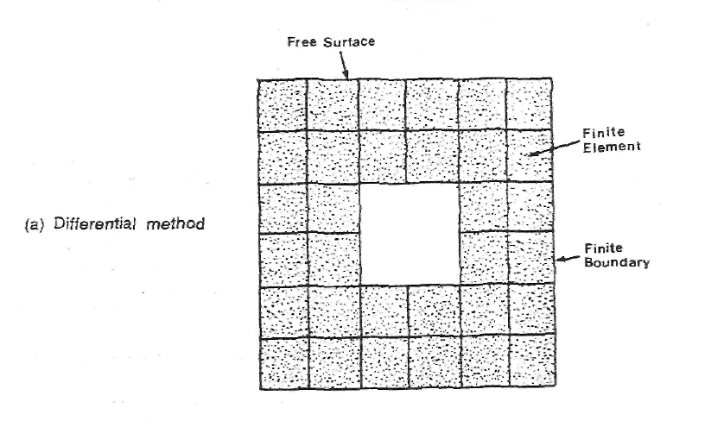
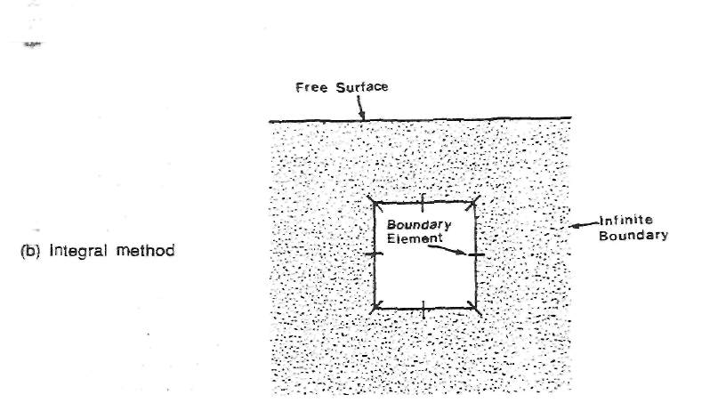
Figure 11.5 Illustrating the differential and integral methods of numerical analysis, after
Brown [11.14]

Numerical design methods have been developed to incorporate non- linear ground and lining behaviour, anisotropic ground behaviour coupled with stratified formations and non-hydrostatic in situ stresses. Nevertheless, they are expensive, time consuming and highly specialised design methods and their application needs careful consideration not only on technical grounds but also economically in terms of time and cost.
A further point regarding numerical design methods is the question of code verification. Essentially, this entails checking that the solutions being produced by a given model agree with independently derived solutions to the same problem [11.15]. If the code of a design method programme has not been verified prior to its use in practice or research, it may well contain some form of error which is not evident to the user. This may have long term practical or other consequences in seme cases.
Empirical methods. An empirical design method is essentially one that is based on in situ observations or measurements made on models from the prototype rock [11.16]. A simple example of this is the use of a database of measured tunnel closures in a variety of ground conditions from which the designer can select a lining type on the basis of its past performance.
The most important empirical design method in relation to tunnelling is possibly that of rock mass classification which involves assessing the competency of the rock mass by determining joint spacings, joint numbers, rock quality designation (RQD) and various other parameters and combining them to form some arbitrary rock index. From this index, an appraisal of support requirements or the stand-up time of the excavation can, very often, be obtained from simple design rules or nomograms which again may be based on past experience.
The area of physical modelling can also be considered as an empirical design method as it is very often used to reproduce effects in the laboratory which have been observed in situ. This often gives an appraisal of possible remedial measures to a given tunnel situation whereby the observed effect at the opening boundary can be accurately reproduced by altering the applied stress conditions to the model and then by assessing the cause in terms of the zone of influence on the opening. Remedial measures can be devised and also assessed using the same technique.
Concluding Remarks
It is of importance that a designer recognises the purpose of a support in a given tunnelling situation so as to apply the appropriate criteria to its design. The restrictions on a support system in various applications has led the wide variety of support methods in current use. It may be that the type and size of a support is governed by non- geotechnical considerations or that the experience of the designer leads him to prefer a particular support in a given situation. This does not preclude the use of geotechnical design, however, or detract from its value. A proper assessment in respect of the geotechnical environment should always be a part of the tunnel design process taking account that the design method employed will not necessarily fully represent the problem under consideration. The skill and experience of the designer will be required to assess the solutions and their applicability to the problem. Additionally, the skill of the designer has been universally recognised as the most important part of all soil and rock mechanics design methods and importantly their interpretations.
References to Chapter 11
- Tough, S.G. and Noskiewicz, E.M. (1974) Preformed linings in tunnelling practice, RETC Proceedings, 1 (47), 643-667.
- Craig, R.N. and Muir Wood, A.M. (1978) A review of tunnel lining practice in the UK, TRRL Supplementary Report 335, 211 p.
- O'Rourke, T.D. (1984) Guidelines for tunnel lining design, ASCE, 82p.
- Kuesel, T.R. (1987) Principles of tunnel lining design, Tunnels and Tunnelling, April, 19, 25-28.
- Muir Wood. A.M. (1979) Ground behaviour and support for mining and tunnelling, 14th Sir Julius Wernher Memorial Lecture, Tunnelling 79, IMM London, A23-A34.
- Peck, R.B. (1959) Deep excavations and tunnelling in soft ground: state of the art paper, Proc. 7th Int. Conf. Soil Mech. & Foundation Eng., Mexico, 225-258.
- Rabcewicz, L (1964/65) The New Austrian Tunnelling Method, Water Power, Nov., 453-457, Dec, 511-515,
Jan., 19-24. 11.8 Rabcewicz, L (1969) Stability of tunnels under rock load,
Water Power, 21, June, 225-22S, July, 266-273, Aug., 297-302.
- Henshaw, H. (1949) The use of timber in mining, Timber Development Association Limited, London, 85p.
2.
- Stassen, P. and van Duyse, H. (1973) Developments of supports in stone roads in the Campine Coalfield, 6th Int. Strata Control Conf., Banff.
- Whittaker, B.N., Carter, M.R., Kapusniak, S.S. and Townley, A.J. (1985) Design and selection of support systems in mine roadways and tunnels with reference to UK coalfields, 9th Plenary Scientific Session, Int. Bureau of Strata Mech., Varna, Bulgaria, 20S-223.
11.12 Hoek, E. and Wood, D. (1989) Rock support, Word tunnelling, April, 2, No.2, 131-136.
- Gibson, R.E. (1974) The analytical method in soil mechanics, 14th Rankine Lecture, Geotechnique, 24,115-140.
- Brown, E.T. (1987) Analytical and computational methods in rock mechanics, Allen and Unwin, Chap.1, 1-31.
- Brady, B.H.G. and St.John, C.M. (1982) The role and credibility of computational methods in engineering rock mechanics, Proc. 23rd US Symp. on Rock Mechanics, 571-586.
- Obert, L and Duvall, W.I. (1967) Rock mechanics and the design of structures in rock, John Wiley, New York, 650p.
- Whittaker, B.N. (1974) An appraisal of strata control practice, The Mining Engineer, October, 166, 9-24.

