**Consolidation:**

Unlike elastic materials like steel in which stresses and strains are produced simultaneously on application of load, in visco-elastic materials like soil stresses are produced but strains are time-dependent. Soil deforms on the application of load and shows its signs even after the removal of load.

**Definition:**

“The rate of decrease of volume of soil with respect to the time is called consolidation.”

**Reasons of Consolidation:**

1. Distortion or change of shape of solid particles.
2. Compression of air and water in soil voids.
3. Expulsion of water or air from the soil.

* Under usual condition change of shape of solid particles due to application of load is very negligible.
* Fine grained soils are usually saturated and amount of air is small, so the expulsion of air is very small.
* Water don’t show significant decrease in volume as well.
* So the consolidation of soil is mainly due to the expulsion of water.

**So “Consolidation is the compression of a soil mass due to expulsion of water when subjected to external compression loads.” Or**

**“The process of change in the soil volume on account of water flowing out of its voids on account of dissipation of excess pore water pressure produced on application of total stress is known as consolidation.”**

**Difference b/w Consolidation and Compaction:**

|  |  |
| --- | --- |
| **Compaction:** | **Consolidation:** |
| * It is artificial process | * It is natural process |
| * It is for any type of soil. | * It is for fully saturated soil. |
| * It is faster process. | * It is slower process. |
| * It involves addition of water. | * It involves expulsion of water. |

* Process of consolidation is faster in non-cohesive soils.
* In cohesive soils permeability is less so water takes more time to come out and consolidation is slower.

**Secondary Consolidation:**

It is due to the plastic deformation as a result of complex colloidal chemical processes whose roles are hypothetical here.

* Out of two types of deformation, the primary consolidation is normally the much larger, easier to predict, occurs at faster rate and is generally the more important. In many problems, however the secondary consolidation is more important particularly in highly organic soils.

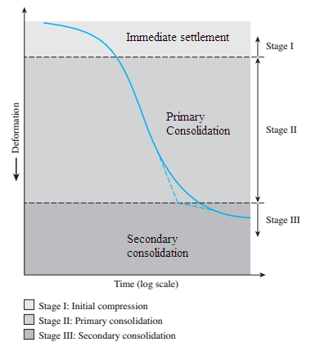

**Consolidation Model (Hydrometer Analogue):**

In this model spring represents the soil minerals and water in the cylinder represents the pore water.

1. In stage 1 initial load (∆P) is applied on the cylinder and initial volume is V.

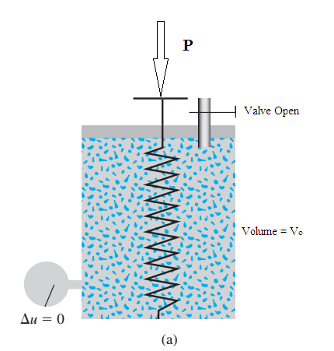

$$σ=σ^{'}+U$$

$$σ=σ^{'}+0$$

So total stress is equal to the effective stress. Effective stress is stress carried by soil solids.

1. Valve is closed and sum additional load is applied and no change in volume occurs and the entire load is carried by pores. So effective stress remains constant.

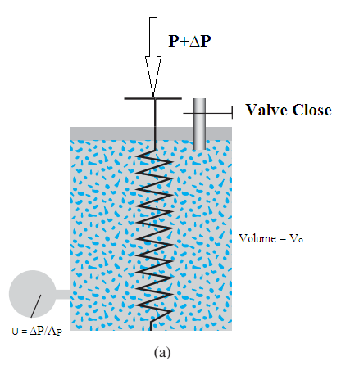

$$σ=σ^{'}+U$$

$$σ=σ^{'}+\frac{∆P}{A_{P}}$$

1. In this stage water starts to escape out and effective stress starts to increase and volume is decreased to V.

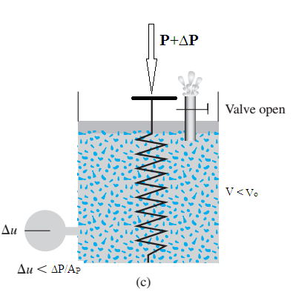

$$σ=σ^{'}+U$$

1. In this stage all the flow has occurred and volume is decreased to V1. Pore pressure is zero and effective stress is equal to total stress.

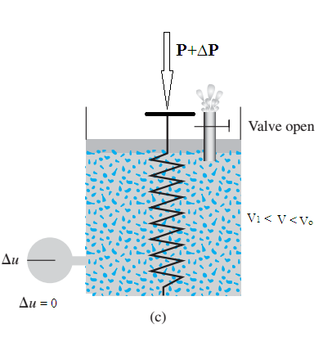

$$σ=σ^{'}+U$$

$$σ={(σ}^{'}+\frac{∆P}{A_{P}})+0$$

And this cycle continues with any further application of load.

* Deformation of soil occurs only when there is a change in effective stress and not occurs when there is change in total stress but no change is there in effective stress.

**One Dimensional Consolidation Theory:**

Terzaghi put forward theory for primary consolidation of soils, with its help it is possible to make a reasonable estimate of the magnitude and rate of settlement of a structure placed on soil. This theory is referred to as one dimensional consolidation theory because of the assumption in this theory is that the flow of water in soil pores takes place in vertical direction only.

In the development of this theory following assumptions were made.

1. Change in effective stress (pressure) in soil causes a corresponding change in void ratio.
2. Seepage flow is restricted to one direction.
3. Darcy’s law is applicable.
4. The soil mass is completely saturated.
5. The deformation is one dimensional i.e. in the direction of flow.
6. The water and soil particles are incompressible.
7. The soil mass is homogenous.
8. The co-efficient of permeability is constant.

* In reality, these assumptions are not fully met. The results from consolidation study however reveal that large discrepancies between theory and nature are brought about by the presence of a large volume of air the voids of soil.

**Constants and Definitions:**

1. Co-efficient of Compressibility:

“It is the ratio of change in void ration and the change in pressure.”

It is denoted by av.

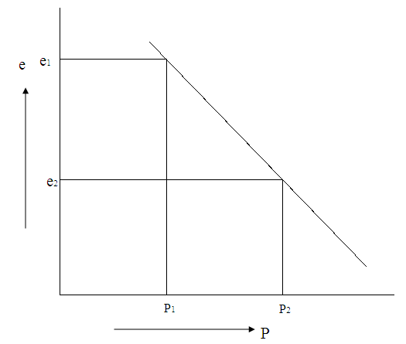

It is found from graph at natural scale between pressure and void ratio. Its units are ft2/lb.

1. **Compression Index:**

If we plot a graph between void ratio on natural scale and pressure on log scale then the ratio is defined as compression index.

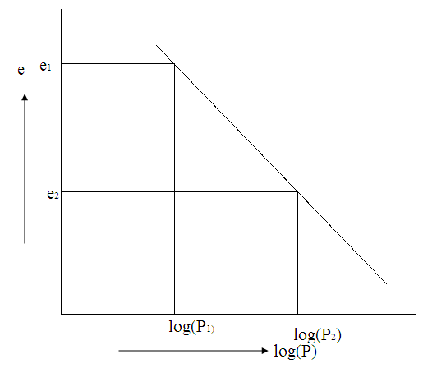

$$C_{c}=\frac{e_{1}-e_{2}}{{logP}_{2}-{logP}_{1}}$$

$$C_{c}=\frac{e_{1}-e_{2}}{log⁡(\frac{P_{2}}{P_{1}})}$$

$$C_{c}=\frac{∆e}{log⁡(\frac{P_{2}}{P_{1}})}$$

It is unit-less quantity.

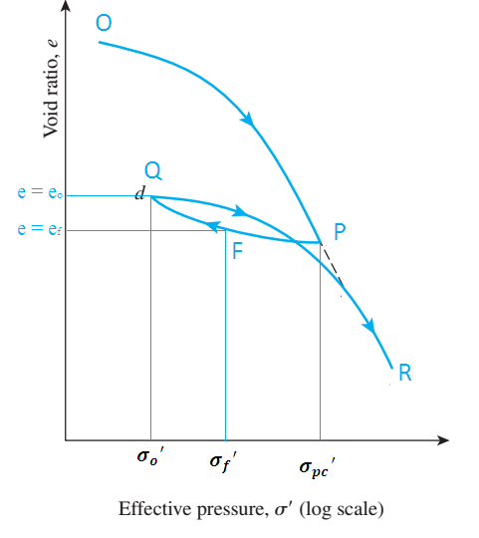

**Co-efficient of Volume Change:**

$$m_{v}=\frac{a_{v}}{1+e_{o}}$$

$$m_{v}=\frac{\frac{∆e}{∆P}}{1+e_{o}}$$

$$m_{v}=\frac{∆e}{∆P(1+e_{o)}}$$

Its units are ft2/lb.

**Degree of Consolidation:**

It is defined as the percentage of the total settlement that has occurred after time t.

$$U=\frac{Settlement after time t}{Total Final settlement}×100$$

$$U=\frac{S_{t}}{S_{f}}×100$$

It is unit-less.

**Time Factor:**

It is a constant derived from the theory.

$$T_{v}=\frac{C_{v}×t}{H^{2}}$$

Where

Cv = Co-efficient of consolidation

H = Drainage path

t = time settlement has been occurring.

To find this time factor we have a relation:

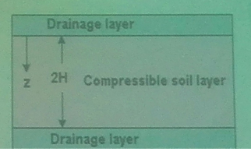

**Co-efficient of Consolidation:**

Cv is a constant derived from the theory where

$$C_{v}=\frac{K}{m_{v}×γ_{w}}$$

Where K is co-efficient of permeability and mv is co-efficient of volume change.

Units: $\frac{\frac{ft}{sec}}{\frac{{ft}^{2}}{lb}×\frac{lb}{{ft}^{3}}}=\frac{{ft}^{2}}{sec}$

For U= 0 to 60%, $T_{v}=\frac{π}{4}×{(\frac{U}{100})}^{2}$

For U > 60% $T_{v}=1.781-0.993 log⁡(100-U)$

For practical purposes relation of U and Tv is as follows:

|  |  |  |  |  |  |  |  |  |  |
| --- | --- | --- | --- | --- | --- | --- | --- | --- | --- |
| U | 10 | 20 | 30 | 40 | 50 | 60 | 70 | 80 | 90 |
| T | 0.008 | 0.032 | 0.07 | 0.125 | 0.197 | 0.29 | 0.41 | 0.57 | 0.848 |

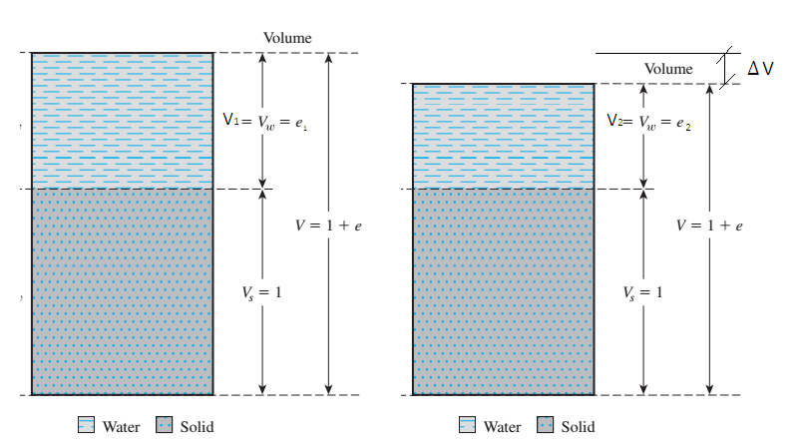

If h1 is total initial height and ∆h is decrease in volume then as the area is constant.

$\frac{∆h}{h}=\frac{∆V}{V}$ eq 1

V may be expressed in terms of e as follows:

$V_{v}=e{×V}_{s}$

$${V_{1}=V}_{s}+V_{V}=V_{s}(1+e_{1})$$

$$\frac{∆V}{V}=\frac{V_{1}-V_{2}}{V_{1}}$$

$$\frac{∆V}{V_{1}}=\frac{V_{s}\left(1+e_{1}\right)-V_{s}(1+e_{2})}{V_{1}}$$

$$\frac{∆V}{V_{1}}=\frac{V_{s}{(e}_{1}-e_{2})}{V_{s}(1+e_{1})}$$

$$\frac{∆V}{V_{1}}=\frac{∆e}{1+e_{1}}$$

$$∆e=(1+e_{1})×\frac{∆V}{V_{1}}$$

Therefore

$$∆e=(1+e_{1})×\frac{∆h}{h_{1}}$$

Or

$$\frac{∆h}{h_{1}}=\frac{∆e}{1+e_{1}}$$

Since $S=∆h$ so.

$$\frac{S}{h_{1}}=\frac{∆e}{1+e_{1}}$$

$$\frac{S}{h_{1}}=\frac{e_{1}-e_{2}}{1+e_{1}}$$

$$S=\frac{e_{1}-e_{2}}{1+e_{1}}×h_{1}$$

Since $$C_{c}=\frac{∆e}{log⁡(\frac{P_{2}}{P_{1}})}$$

$S=C_{c}×\frac{log⁡(\frac{P_{2}}{P_{1}})}{∆e}×\frac{e_{1}-e_{2}}{1+e_{1}}×h_{1}$

$$S=C_{c}×\frac{log⁡(\frac{P_{2}}{P_{1}})}{1+e_{1}}×h_{1}$$

$$S=\frac{C_{c}×h_{1}}{1+e_{1}}log⁡(\frac{{σ_{o}}^{'}+∆σ^{'}}{{σ_{o}}^{'}})$$

$$\frac{∆h}{h_{o}}=\frac{∆e}{1+e_{o}}$$

$$∆e=\frac{∆h(1+e_{o})}{h_{o}}$$

$$m_{v}=\frac{∆e}{∆P(1+e_{o)}}$$

$$m_{v}=\frac{\frac{∆e}{1+e_{o}}}{∆P}$$

$$m_{v}=\frac{\frac{∆h}{h_{o}}}{∆P}$$

$$S={∆P×m}_{v}×h$$

$$S=\frac{a_{v}×h}{1+e_{o}}∆P$$

**Determination of Coefficient of Consolidation ‘Cv’ from Lab Consolidation Test:**

Only two method for determination of ‘Cv.’ will be discussed, one by Taylor and another by Casagrande. Although empirical in nature, they are rather simple and expedient, and gives results that are comparable to some developed from theoretical expressions. The value of Cv for a particular increment in the oedometer test can be determined by comparing the characteristics of the experimental and theoretical consolidation curves, the procedure being referred to as curve fitting.

The characteristics of the curves are brought out clearly if time is plotted to a square-root or logarithmic scale.

**Determination of ‘Cv’ From Lab Consolidation Test:**

A) Taylor’s Square Root of Time Fitting Method.

B) The Log Time Method (Due to Case to Casagrande).

1. **Taylor’s Square Root Of Time Fitting Method:**

The method consist of drawing the curve between root of time as abscissa and the dial reading R representing the compression of specimen as ordinate for any pressure increment in the consolidation test.

Fig a Shows a theoretical characteristic curve between under root of time factor (Tv) and degree of consolidation (u). The curve is straight up to u = 60% and the abscissa at u = 90% is equal to 1.15 times the abscissa at u = 60%. The use of this characteristic of the theoretical curve to determine the 90% u point on a laboratory time consolidation curve was suggested by Taylor (1948).

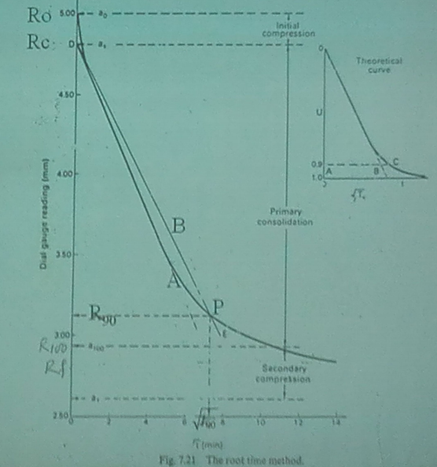

The initial dial reading R0 corresponds to the point t = 0 and u = 0. The straight portion (line A) is produced back to meet the ordinate at reading R, which is called the corrected zero reading and the consolidation between R0 and Rc is called initial consolidation. From R. another line “B” is so drawn that its abscissa at every point is 1.15 times that of line “A”. The intersection of line B with the consolidation curve gives a point “P” corresponding to u = 90%, whose dial reading and time may be designated as R and t respectively.

If required the point of R100 on the experimental curve corresponding to U = 100% , the limit of primary consolidation can be obtained by proportion. The co-efficient of consolidation is calculated from equation. Figure b shows such a plot.

$$C_{v}=\frac{T_{v}d^{2}}{t}$$

$$C_{v}=\frac{T_{v}H^{2}}{t}$$

**Explanation by Sir Irfan:**

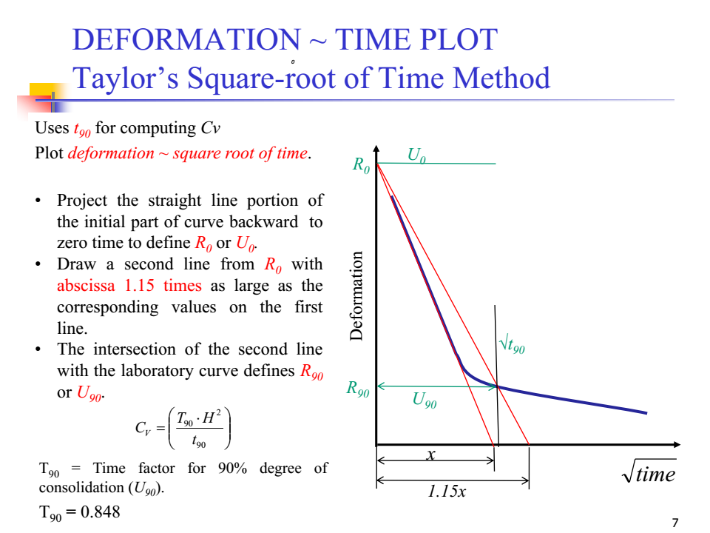

1. **THE LOG TIME METHOD (due to casagrande):**

The log time method (due to Casagrande), the forms of the experimental and theoretical curves are shown in fig. The experimental curve is obtained by plotting the dial gauge readings in the oedometer test against the logarithm of time in minutes. The theoretical curve is given as the plot of the average degree of consolidation against the logarithm of the time factor.

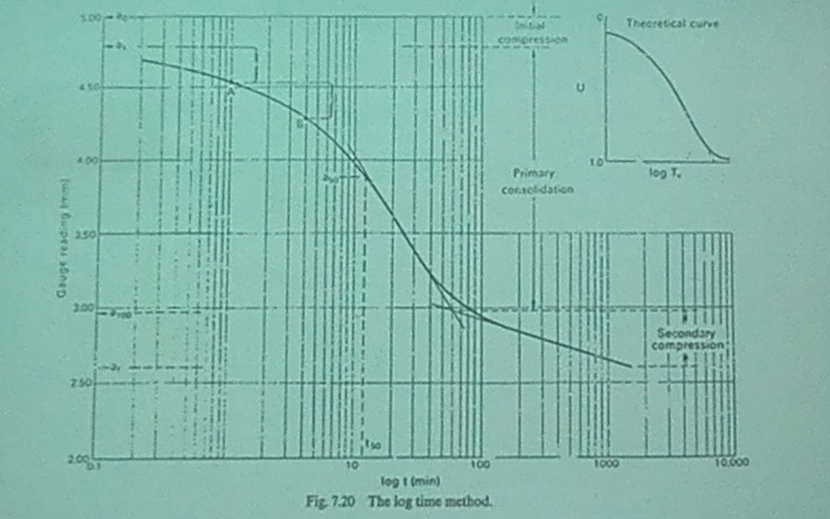

**Explanation by Sir Irfan:**

Used to determine Cv (coefficient of consolidation)  
• Rate of consolidation  
• Consolidation Time

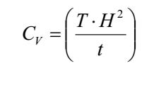

t50: obtained from deformation ~ time plot

H = t/2 (for two-way drainage)  
t = height of specimen  
T = Time factor = 0.197 (for u=50%)

**•Plot specimen deformation against log-of-time:**  
•R0 and R100 represent dial readings for zero percent  
(U0) and 100% (U100) degree of consolidation  
respectively.  
**•For determining U100:**  
•Draw two tangents to the bottom part of curve, intersection of these tangents represent U100.  
•The corresponding abscissa represents t100.  
**•For determining U0:**  
•Choose any two times t1 and t2, such that t2 = 4t1  
•The corresponding dial readings are R1 and R2  
•Mark off vertical distance between R1 & R2 (say ‘x’)  
•R0 lies ‘x’ distance above R1.  
•R50 represents 50% degree of consolidation (U50).  
•R50 lies mid-way between R0 and R100.  
•The time (t50) is used for determination of Cv.

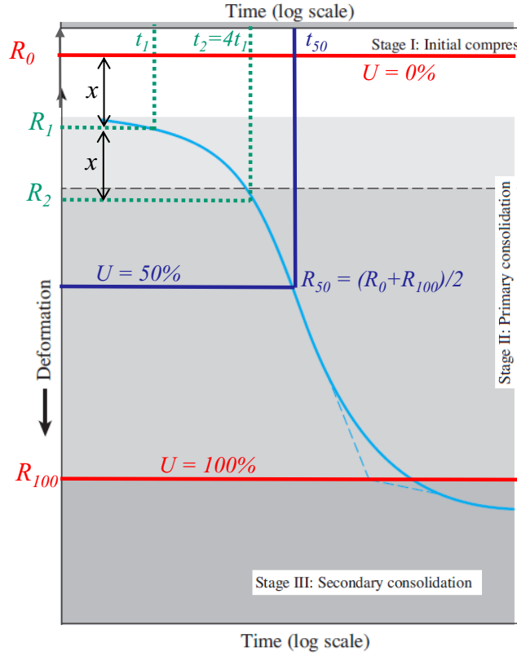

**Permeability:**

**Definition:**

Permeability is defined as the property of a porous material (soil) which permits the passage or seepage of water (or other fluid) through its inter-connecting voids.

A material having continuous voids is called permeable e.g. gravels are highly permeable. While stiff clay may be termed impermeable for all practical purposes.

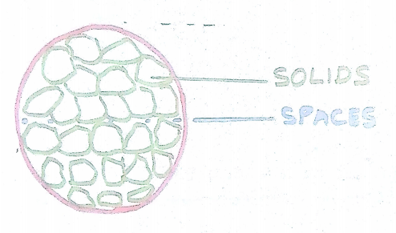

**Importance of Permeability:**

Among the engineering problems where soil permeability may play quite a prominent role are:

* Quantity of leakage through and under dams.
* Rate of consolidation and related settlements.
* Calculation of uplift pressure present under hydraulic structure.
* Stability of slopes and embankments.
* Seepage velocity v through the soil which may create erosion (piping effects) via transportation of fine-grained particles.

**Laminar Flow:**

Laminar flow, each fluid particle travels along a definite path which never crosses the path of any other particles.

**Turbulent Flow:**

In turbulent flow, the paths are irregular and twisting, crossing and re-crossing at random. In most of the practical flow problems in soil mechanics, the flow is laminar.

**Flow of Water through Soil:**

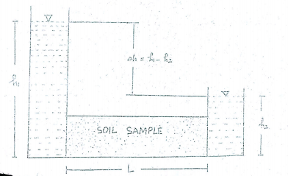

**Hydraulic Gradient or Hydraulic Grade Line:**

It is the line joining the pressure head in the beginning (top of water level at the inlet) with the pressure head at the end (end of the pipe). In an open channel the hydraulic grade line in the water surface.

**Darcy’s Law:**

The velocity of flow through soil is proportional to hydraulic gradient  
v ∝ i  
v = k . i

Where

v = discharge velocity.  
(i.e., the quantity of water flowing in unit time  
through a unit cross-sectional area of soil)  
k = hydraulic conductivity (has units of L/T)  
i = hydraulic gradient = h/L  
Then the quantity of water flowing through the soil per unit  
time is  
Discharge = Q = v. A = k (h/L). A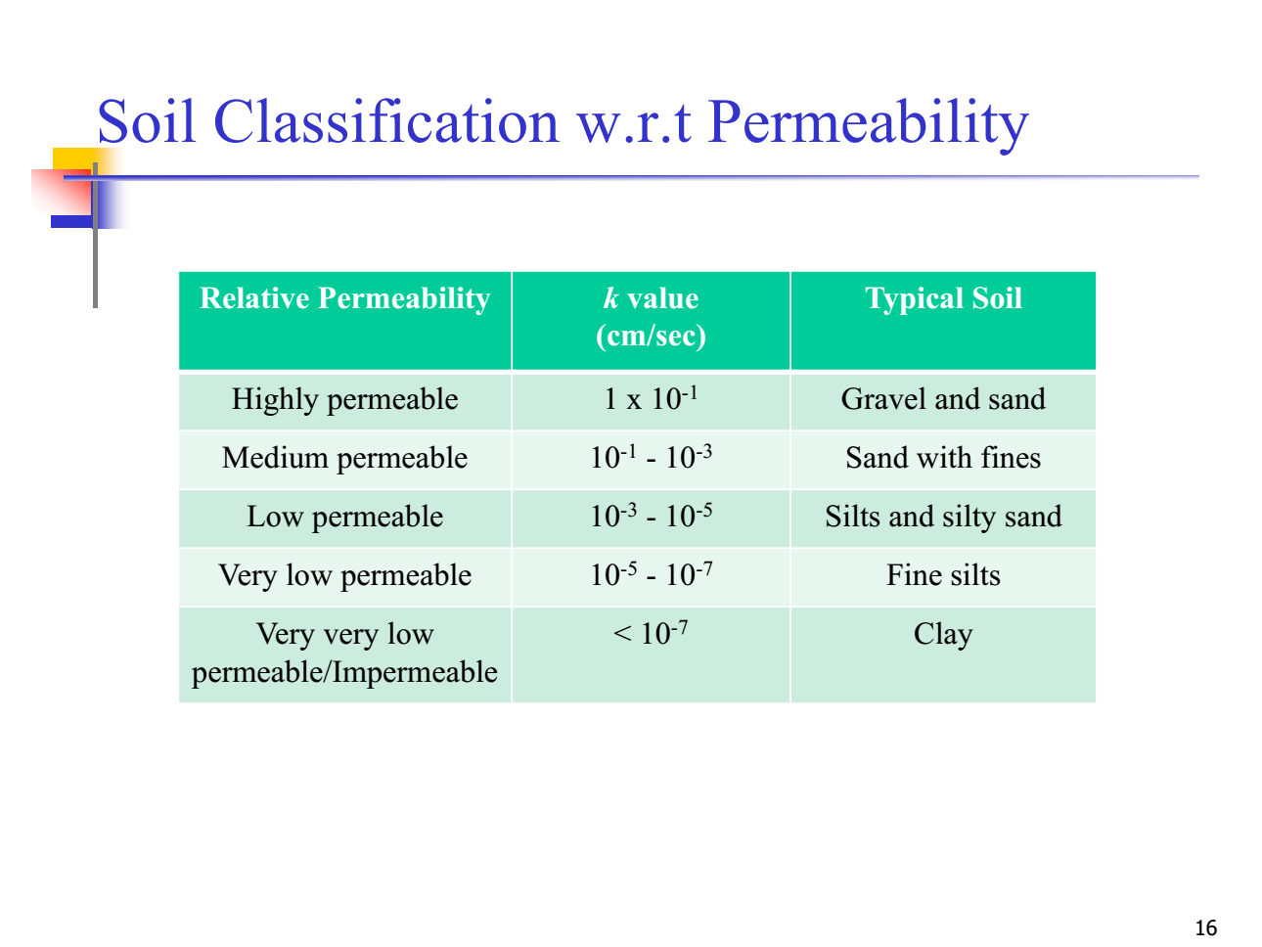

**Discharge Velocity & Seepage Velocity:**

Consider a soil sample where dimension into paper is unity as shown in figure.

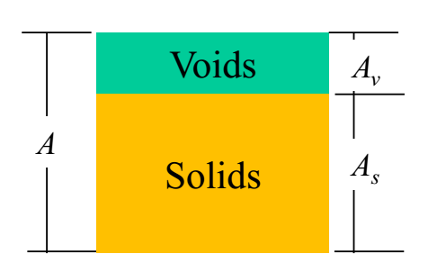

In Darcy’s law the velocity of flow V is the rate of discharge of water per unit of total cross-sectional area A of soil. This total area of cross-section is composed of the area of voids Av. Since the flow takes place through the voids only the actual or true velocity of flow will be more than the discharge velocity.

This actual velocity is called the seepage Velocity Vs and is defined as the rate of Discharge of percolating water per unit cross-sectional area of voids perpendicular to the direction of flow. .

Vs = Seepage velocity or Actual velocity of flow

V= Average e velocity or superficial velocity. (Vs > V)

If Q = total flow/discharge through soil mass, then

Average velocity = V = Q/A

Seepage velocity = Vs = Q/Av

From the above diagram

A = Av + As

Dividing both sides by As

A/As = Av/As + As/As

A/As = Av/As +1

As the third dimension (into paper) of soil mass is supposed to be unity therefore:

Av * 1 = Vv and As * 1 = Vs where

Vv = volume of voids and

Vs = volume of soil solids.

A/As = Av/As +1

A / (A-Av) = e + 1

A-Av = A / (e + 1)

-Av = A / (e + 1) - A

-Av = A (1 / (e + 1) - 1)

Av = A (e / (e + 1))

Vv = V*n

Total Discharge = Q = A * V = Vs * Av

Q = Vs * A * n

Therefore

V = n * Vs

**Determination of Co-efficient of Permeability:**

Co-efficient of Permeability can be determined by the following methods:

**D1RECT METHODS:**

These include

**Laboratory methods:**

* These are Constant permeability test
* Variable head or falling head permeability test.

**FIELD METHODS:**

These are:

* Test Wells
* Infiltration Galleries

**INDIRECT METHODS:**

* Computation from grain size or specific surface.
* Consolidation test data

**LABORATORY PREMEABILITY TESTS:**

These are two basic designs of apparatus used in laboratories for estimating the coefficient of permeability K of soils:

* Constant head permeameter.
* Falling head permeameter.

Permeability is some time also estimated from the rate of consolidation, but the value is generally unreliable. There are other factors influencing the consolidation rate which are difficult to account for in a relevant manner.

A more advisable procedure entails subjecting the specimen to a constant—head permeability or falling head permeability test.

**Permeameter:**

A permeameter is an apparatus used for determining the coefficient of permeability of soil.

**Constant Head Vertical Permeameter:**

A constant head permeameter consists of a vertical cylinder containing the soil sample for which the coefficient of permeability is to be determined. The soil sample can be in a disturbed state or undisturbed state.

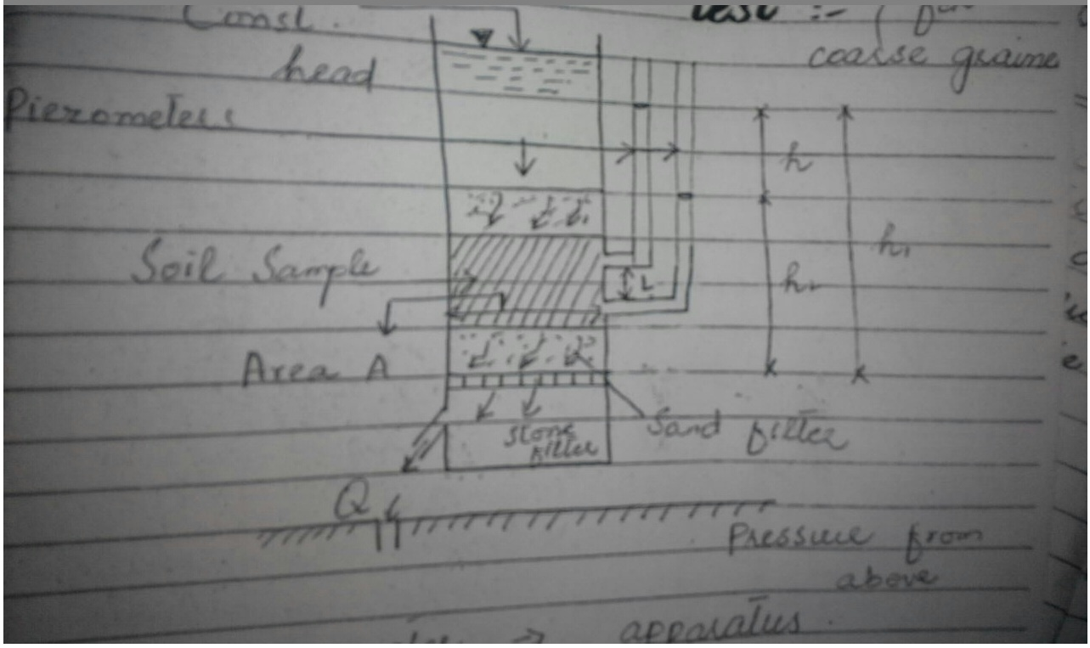

Two or more Peizometric tubes are attached to the permeameter cylinder spaced a distance, “L” apart. The horizontal cross— sectional area of the cylinder, viz. soil sample, perpendicular to the direction of flow of water through the soil sample is “A” cm. T he test cylinder is connected through its top by means of a pipe to a water or pressure reservoir, as shown in Figure. Thus, water pressure is applied, and water enters the permeameter from top of the specimen giving a downward flow.

The amount of water “v” in cm3 flowing during a certain time “t” seconds, is collected in a graduate cylinder; the temperature of the water is measured; the pressure difference h = h1 — h2 (Note that is constant) is determined, which is the loss in head spent for over-coming the resistance to flow over a length of flow “L”, through the soil sample, and the following quantifies are calculated.

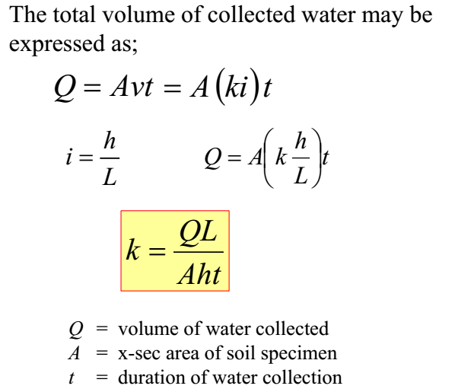  
The coefficient of permeability is to be corrected for viscosity and reported at 200 C as:

K20 = K (n/n20)

A constant head permeameter with water seeping through the soil sample from its bottom is illustrated in figure.

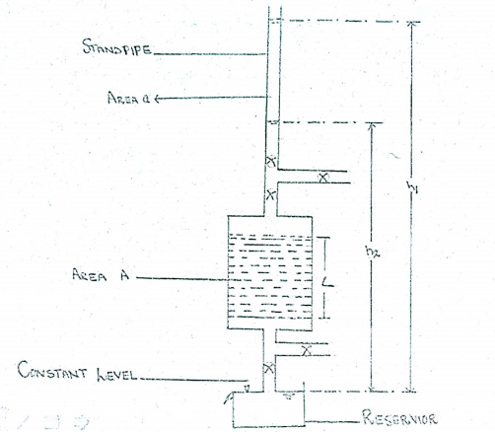

The quantities to be observed and determined are the same as with constant head permeameter with water seeping through the soil sample from top.

The constant head permeability test is more suited for coarse soils such as gravelly sand and coarse and medium sand.

**PERMEABILITY CORRECTION FOR TEMPERATURE:**

In soil mechanics research and practice, for purpose of comparison, the coefficient of permeability “K”, is conventionally reported at a stand temperature of +20°C. Therefore, coefficients of permeability obtained at temperature other than standard are to be corrected for the viscosity of water at +2O°C. The coefficient of permeability at +20°C, K, is calculated as

K20 = K (n/n20)

Where

K = Coefficient of permeability obtained at some temperature T other than +20°C

n = Coefficient of dynamic viscosity in Poises at some temperature T other than +200 C.

n20 = Co-efficient of dynamic viscosity at +20°C.

**Falling Head Permeameter:**

For fine-grained soils the falling head or variable head permeameter should be used.

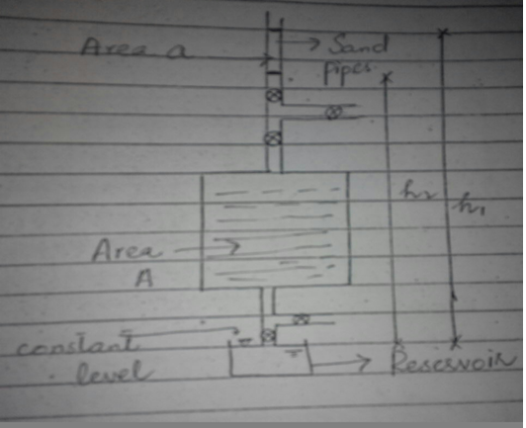

In the case of fine-grained soils, undisturbed specimens are normally tested and containing cylinder in the test may be the sampling tube itself. The length of the specimen is L and cross-sectional area is A. A coarse filter is placed at each end of the specimen and a standpipe of internal area “a” is connected to the top of the cylinder. Sample is allowed to saturate fully. Water drains into a reservoir of constant level. The standpipe is filled with water and a measurement is made of the time t for water level (relative to the water level in the reservoir) to fall from h1 to h2. At any intermediate time t water level is h. During time interval dt the height of column of water drops by –dh. Negative sign indicates h decreased with time t.

If

L = Length of specimen

A = Cross-sectional Area of specimen

a = Cross-sectional area of standpipe

h1 = Initial head

h2 = Final head

-dh = Fall of head in time t then

$$Q=K i A=Vel a$$

$$Q=K\frac{dh}{dr}A=\frac{-dh}{dt}.a$$

$$K dt \frac{h}{L}A=-dh.a$$

$$\frac{A}{L}K\int_{0}^{t}{=-a\int_{h_{1}}^{h_{2}}{\frac{dh}{h}}}$$

$$\frac{AK}{L}.t=-a ln⁡(\frac{h_{2}}{h_{1}})$$

$$\frac{AK}{L}.t=a ln⁡(\frac{h_{1}}{h_{2}})$$

$$K=2.303\frac{AL}{At}\log_{10}\left(\frac{h_{1}}{h_{2}}\right)$$

**Well:**

Well is an artificial usually vertical, cylindrical perforated hydraulic structure provided with a screen that taps ground water from the voids of soil which it penetrates. Wells are lined to prevent them from caving in.

**Aquifer:**

The pervious layer is termed as aquifer or aquifer is bearing stratum of soil from which water acting as ground water storage is tapped out.

**Ordinary or Gravity or Discharge or Unconfined Well:**

A well sunk into water bearing stratum and tapping free flowing ground water having a free ground water table under atmospheric pressure is termed as ordinary or gravity or discharge or unconfined well.

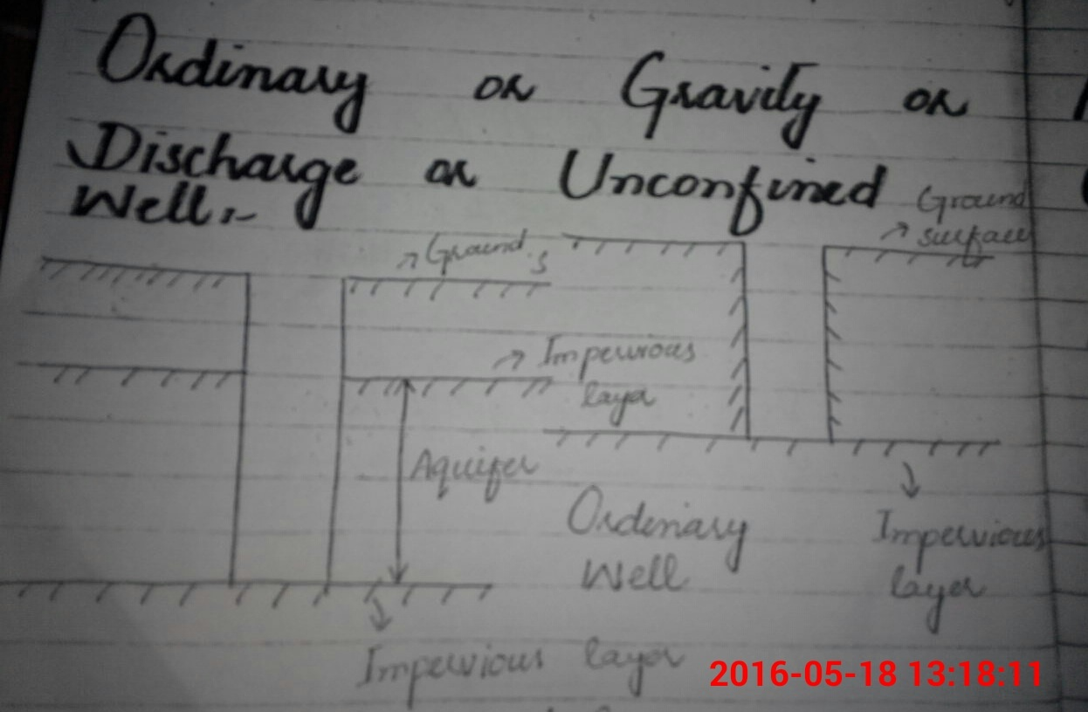

An ordinary well is a well in which the surface of water inside and outside the well when not being pumped is under atmospheric pressure. The inside and outside of the well is connected through the well screen.

**Artesian or Pressure or Confined Well:**

A well sunk into and tapping water from an aquifer where the ground water flow is confined between two impermeable soil layers and under pressure greater than atmospheric pressure is termed as artesian or pressure or confined well. In the casing of an artesian well, water rises under pressure to a considerable height above the ceiling of the stratum to which it was confined before relieved by the construction of the artesian well to as height equivalent to the hydro-static pressure under which the flow takes place.

**Radial (Well) Flow:**

A radial flow is one where the direction of flow at every point is towards, or from some point on the axis of the symmetry of the well system. The ground water flow to a well or out of it is assumed to be radial.

**Field Determination of Permeability:**

No matter how carefully laboratory permeability test are made, they represent only minute volumes of the soil. While in field tests are made on greater volume of soils.

**Pumped Well With Observation Holes:**

**a) Unconfined We1l:**

Figure represents the basic schematic of one of several methods used in determining the coefficient of permeability in the field. The method involves the use of three wells and a pump. A perforated casing is sunk through the porous stratum into the impervious stratum.

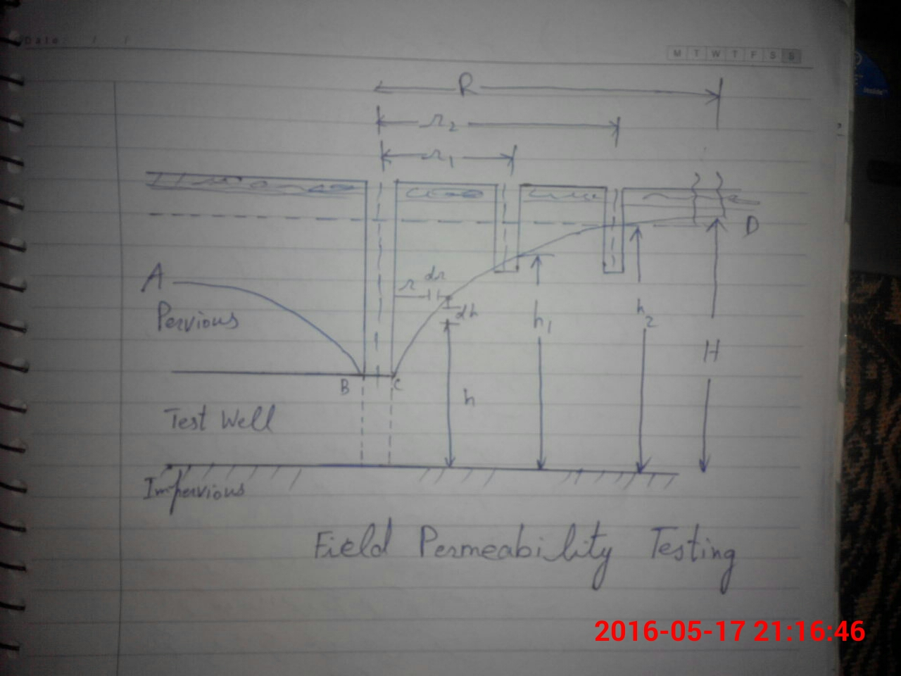

The water in the well is then pumped out and original ground water table O.G.W.T is lowered. The amount of lowering close to the well is more than that away from the well and this is known as draw-down. Initially inflow is different from outflow till a stage reaches when inflow equals the outflow. This stage is known as steady state and flow becomes stable. At the steady state, a cone of depression ABCD is developed and is known as pumping ground water table. The line ABCD is called the depression line and the radial distance “R” where draw-down is zero is termed as the “radius of influence” of the well.

The steady state flow can be determined by observing that the level of water in the test well remains at a relatively fixed elevation with continuous pumping. When this occurs, the level of the water in the two observation wells is recorded; also the distance of each observation well from the test well is recorded.

Now let us assume that the water flows into the well in a horizontal, radial direction through the walls of the casing. The surface area of a cylindrical section of radius ‘r’ and height h is (2*pi*r*h). From Darcy’ s Law

Q = kiA

Where

I = dh/dr; and assuming that total discharge ‘Q’ equals the flow into the well (Steady state flow).

$$Q=K\frac{dh}{dr}A$$

$$Q=K\frac{dh}{dr}2πrh$$

$$Q\frac{dr}{r}=2πKhdh$$

$$Q\int_{r_{1}}^{r_{2}}{\frac{1}{r}=2πK\int_{h_{1}}^{h_{2}}{dh}}$$

$$Q.\ln\left(r_{2}-r_{1}\right)=\frac{2πK}{2}({h_{2}}^{2}-{h_{1}}^{2})$$

$$Q.\ln\left(\frac{r_{2}}{r_{1}}\right)=πK({h_{2}}^{2}-{h_{1}}^{2})$$

$$K=\frac{Q.ln\left(\frac{r_{2}}{r_{1}}\right)}{π({h_{2}}^{2}-{h_{1}}^{2})}$$

$$K=\frac{2.303Q.\log_{10}\left(\frac{r_{2}}{r_{1}}\right)}{π({h_{2}}^{2}-{h_{1}}^{2})}$$

**Confined Well:**

A schematic representation for determining the co-efficient of permeability is as in the field for a confined aquifer is shown.

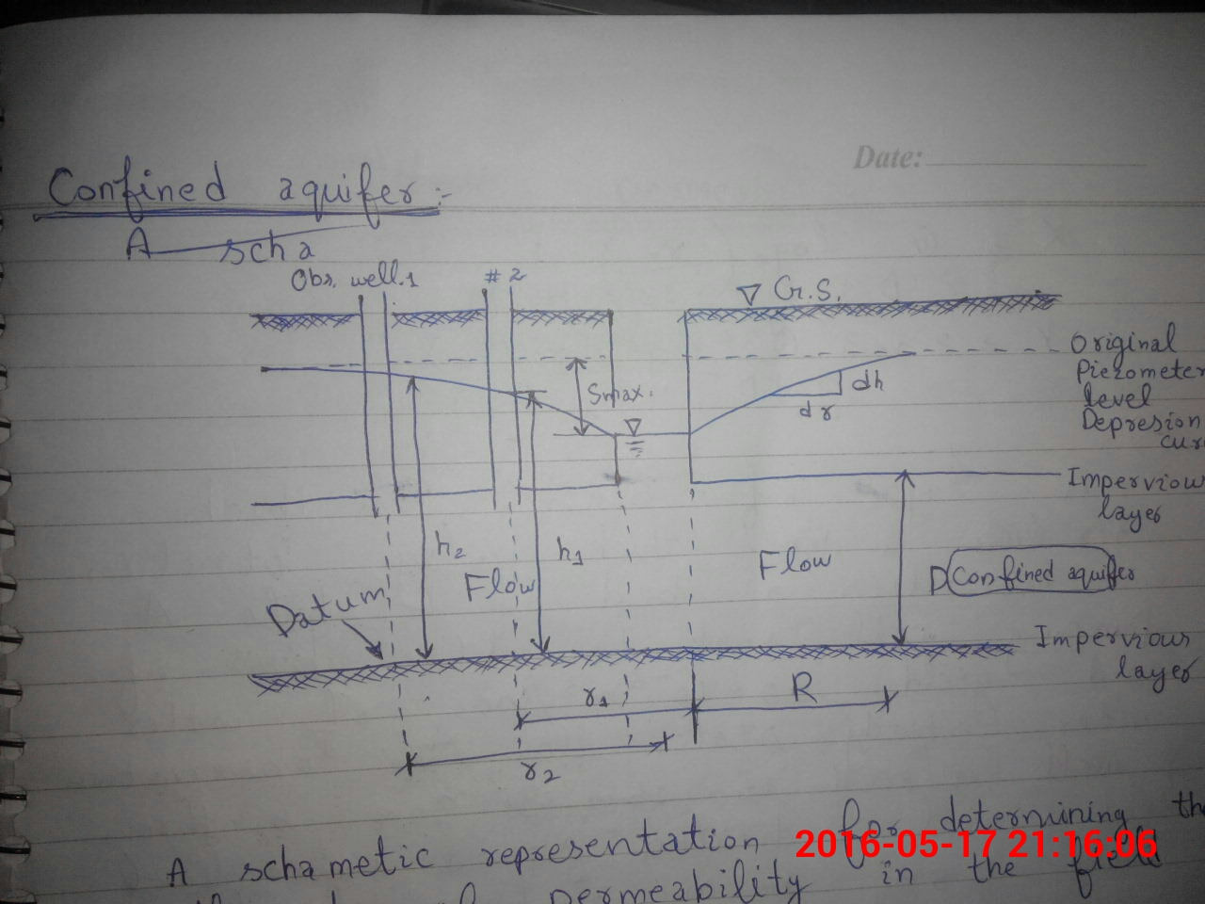

Here

If D = Thickness of the aquifer then the surface area is equal to 2 $π$ rD.

$$Q=K\frac{dh}{dr}A$$

$$Q=K\frac{dh}{dr}2πrD$$

$$\frac{Q}{2πKD}\int_{r_{1}}^{r_{2}}{\frac{1}{r}=\int_{h_{1}}^{h_{2}}{dh}}$$

$$\frac{Q}{2πKD}.\ln\left(\frac{r_{2}}{r_{1}}\right)=h_{2}-h_{1}$$

$$K=\frac{Q}{2πD}\ln\left(\frac{r_{2}}{r_{1}}\right)(\frac{1}{h_{2}-h_{1}})$$

$$K=2.303\frac{Q}{2πD}\frac{\log_{10}\left(\frac{r_{2}}{r_{1}}\right)}{{(h}_{2}-h_{1)}}$$

**Factors Affecting Permeability:**

$$q=(C\frac{γ_{w}}{μ}\frac{e^{3}}{1+e}{D_{s}}^{2})×i×A$$

Above equation is called the poiseuille’s law adapted for the flow through the soil pores.

Where

C = Constant

$μ$ = Viscosity

$e$ = Voids ratio

Ds = Diameter of sphere

$A$ = Area of cross-section

Comparing it with Darcy’s Law:

Q = K I A

We get

$K=(C\frac{γ_{w}}{μ}\frac{e^{3}}{1+e}{D_{s}}^{2})$ eq (1)

* So the factors affecting permeability are:

1. **Size and Shape of Particles:**

Permeability varies approximately as the square of the grain size. Since soils consist of many different grain sizes, some specimen grain size has to be used for comparison. Allen Hazen 1892 based on his experiments on filter sands of particles between 0.1 and 0.3 mm found that the permeability can be expressed as:

K = C (D102)

Where D10 = Effective diameter and C = Constant appr. 100 when D is in cm.

Attempts have been made to correlate the permeability with the specific surface of the particles. One such relation is given by Kozeny (1907).

$$K=\frac{1}{K_{h}×μ×S^{2}}×\frac{n^{3}}{1+n^{2}}$$

$K_{h}$ = 5 for spherical particles.

$S$ = Specific surface of particles.

1. **Properties of Pore Fluid:**

Equation No. 1 shows that the **permeability is directly proportional to the unit weight of water and inversely proportional to its viscosity**. Though the unit weight of water does not change much with the change in temperature, there is a great variation in the viscosity with temperature. Hence when other factors remain constant, the effect of properties of water on the values of permeability can be expressed as:

$\frac{K_{1}}{K_{2}}=\frac{μ_{2}}{μ_{1}}$

1. **Effect of Void Ratio:**

$$\frac{K_{1}}{K_{2}}=\frac{\frac{C_{1}{e_{1}}^{3}}{1+e_{1}}}{\frac{C_{2}{e_{2}}^{3}}{1+e_{2}}}$$

* Factor C changes very little with the change in voids ratio of un-stratified samples.
* For clays it varies appreciably.
* For coarse-grained soils
$$\frac{K_{1}}{K_{2}}=\frac{\frac{{C_{1}}^{3}}{1+e_{1}}}{\frac{{C_{2}}^{3}}{1+e_{2}}}$$

* Another relation based on concept of mean found that semi-log graph of void ratio versus permeability is a straight line.

$$\frac{K_{1}}{K_{2}}=\frac{{e_{1}}^{2}}{{e_{2}}^{2}}$$

1. **Structural Arrangement of Particles and Stratification:**

At some void ratio, structural arrangement may vary depending upon deposition and compacting. Structure of disturbed sample is different from undisturbed sample. Effect of structural disturbance is more on fine-grained particles. Stratified particles have different permeability in directions parallel and perpendicular to stratification. It is greater in parallel direction

1. **Degree of Saturation:**

Permeability is greatly reduced for entrapped air in voids reducing its degree of saturation. The dissolved air in pore fluid (water) may get liberated thus changing the permeability. Ideal conditions for consolidation when measuring permeability is air free distilled water and soil is completely saturated. However percolating water in field may have gases in it so it may also appear more realistic to use actual field water in the experiment. Organic foreign matter also have tendency to move towards critical flow channels and choke them up, thus decreasing the permeability.

1. **Adsorbed Water:**

The adsorbed water surrounding the fine soil particles is not free to move and reduces the effective pore space available for the passage of water. According to a crude approximation after Casagrande, 0.1 may be taken as the void ratio occupied by adsorbed water and permeability may be assumed to be proportional to the square of the net void ratio of (e-0.1).

**Permeability Parallel to Stratification:**

**Parallel to Bedding Planes:**

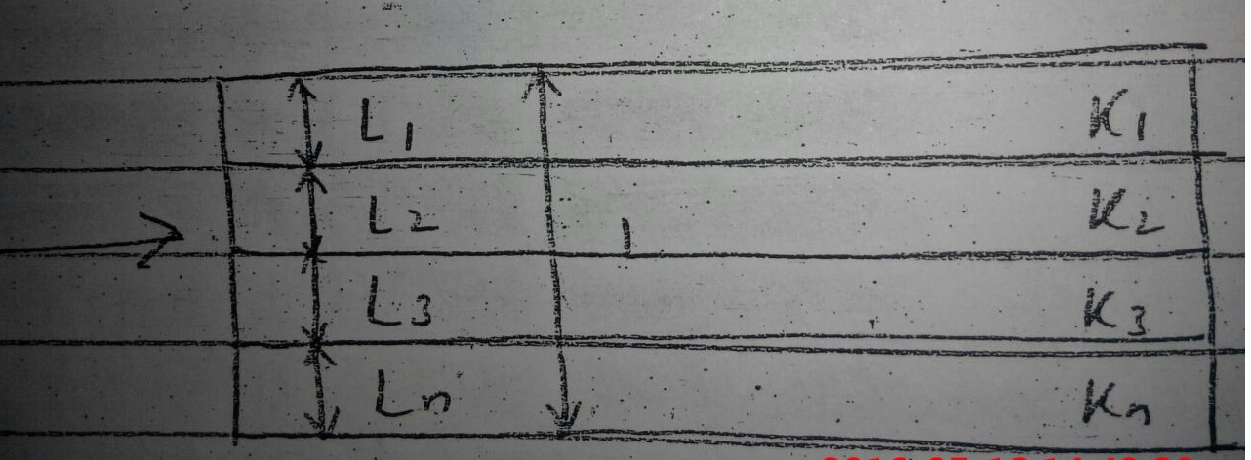

L1 + L2 + L3 + ……… + Ln = L = Thickness of bedding plane.

K1, K2, …… Kn are co-efficient of permeability of different layers.

i = Hydraulic Gradient

Total Discharge = Sum of discharges at different levels

Q = Kh * i * L

$$K_{h}=\frac{K_{1}L_{1}+K_{2}L_{2}+K_{3}L_{3}+……K_{n}L_{n}}{L}$$

**Perpendicular to Bedding Planes:**

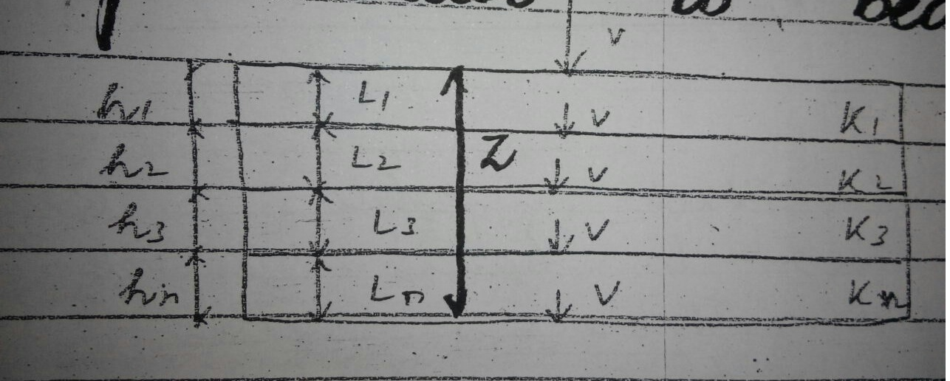

h = Total head loss

h = h1 + h2 + …….. hn

But h1 = i1 L1, h2 = i2 L2 …….. hn = in Ln

So h = i1 L1 + i2 L2 …….. + in Ln eq(1)

Q and Vel are constant.

Kv = Average K perpendicular to bedding

V = Kv i = Kv (h/L)

Or h = V.L / Kv eq(2)

i1 = V / K1, i2 = V / K2 , ……… in = V / Kn eq(3)

h = i1 L1 + i2 L2 + ……… in Ln

Putting values of h, i1, i2, …… in from eq 2 and 3 into eq (1)

*V.L / Kv = V.L1 / K1 + V.L2 / K2 + V.L3 / K3 + V.Ln / Kn*